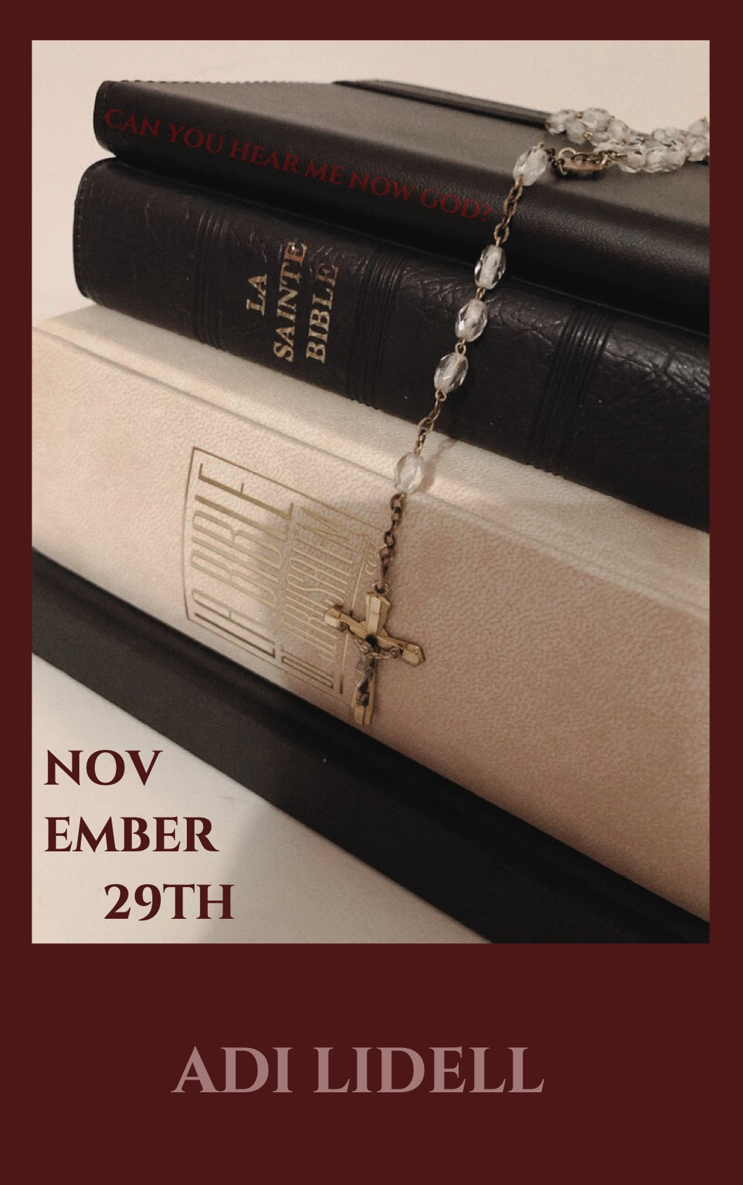

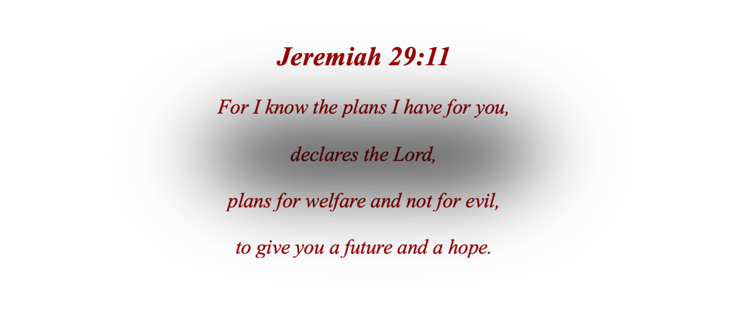

Prologue

November 29th, 1993, 2:45 PM — Ashgrove high school, Greenwich, Connecticut.

If the story of your life was published as a book for anyone to read, what would be the opening chapter? What would be the defining moment that made your reader drop the book from their hands? I always thought that God was writing my story for me, and he had always known the plan of my life. If that however happened to be the case then why had this happened, how did trusting God with the trajectory of my very sole life get me here?

I never thought that lying grotesquely out of breath on the cold terrazzo floors of Ms Warners history classroom would be God’s exodus for us all, then again, Luke did say that whoever desires to save his life will lose it.

1

November 29th, 1993, 10:18 AM — Ashgrove high school, Greenwich, Connecticut.

The piercing shrills of the third period warning bell blasts through my ears like a snare drum causing me to snap awake. Still completely mazed from my sleep I notice the small pool of drool puddled next to my face on my desk. Shoot. I’ve managed to sleep through the entirety of second period. I slowly haul myself out of my seat and begin to collect my books. I try to get myself out of the classroom as quickly as possible, allowing as little opportunity as possible for Mr Hampson to stop me for a ‘check in’. Dozing off in class is certainly not something most people would associate with my character, but I was kept up all night by my parents fighting, something about my dad going away again on another “business trip”. I gave up listening and held my pillow against my ear around 2AM.

Slowly, I make the 30-foot walk down the corridor to my locker to change my books before English. I turn the code on my lock causing the small metal door to click and spring open. A few small torn pieces of notebook paper fall out and land at my feet. Picking them up I notice they all have small bits of writing scribed on them.

“Hey freak, sleep well?” the first reads. The second “Virgin Mary, I’d ask you out for dinner but wouldn’t want to get you in trouble with the convent.”

Stinging pools of tears brim at the bottom of my eyelids as I read them again and again, every carelessly scrawled word burning into my mind like scripture. I scrunch the notes into my hands until the words written are unrecognisable on the page and toss them into the small metal trash can that is stuck to the inside of my locker door. The empty silence of my haze is then quickly interrupted by the final third period bell alerting me that for the second time already this morning, I’m tardy. Before I have a chance to groan about the detention slip I’m sure to have waiting for me once I get to class, a penetrating scream floods my ears and runs down to my bones, then –

A bang.

A bullet.

I freeze.

2

November 29th, 1993, 10:26 AM — Ashgrove high school, Greenwich, Connecticut.

Before I can think, I jump into my locker and slam the door shut. I try to collect myself as much as possible and bring my face closer to the three slits in my locker door so I can gather what’s going on outside. I notice a sweaty red-faced young man holding a rifle, staggering down the empty corridor, growing closer and closer with each step, muttering incessant things to himself that I can’t quite make out. He begins to approach the janitorial closet that sits directly across from my locker door stumbling horribly with each step. Once he reaches the closet, he beats the door down with a kick and then without warning, another bullet punches out of the rifle clasped in his hands.

My body and soul are silenced. My resonant heartbeat pounds through me like the closet door he obliterated only moments before. An uncontrollable flood of tears pours down my face as I try desperately not to let out a sound and alert him that I’m there. I clasp my hands together with such force I’m sure to leave a bruise. I recite my desperate prayers over and over in my mind in the hopes that God will hear me without me having to speak. The faint sulfureous smell of gunpowder smoke wafts through the grates of my locker, only momentarily masking the metallic blood stench pooling out of the closet and staining the corridor.

The man places the rifle back into his jacket pocket like it was nothing but an old gum wrapper. As he turns back towards the closet, childlike cries sound from inside.

“Please, I’m only thirteen” the boy cries.

“I’m only a child, please I haven’t even had a chance to live”.

Plea after plea.

Each ‘please don’t hurt me’ stripping down his voice until its bare and whimpering, like a whisper from God. Mercilessly ignoring his pleads for life, the man wraps his hands around the boys arms and rips him across the hallway, his legs desperately treading air trying to get a grip on the floors enough to stand up and get away.

He fails.

The man then, just as mercilessly as he carried him there, throws the boy into the classroom and abruptly slams the door shut, fashioning a lock with a broom stick through the door handle. It’s just as he turns around to walk back down the corridor, that the small metal trash can that was stuck to my locker door, falls to the ground.

My locker door slams open and there he is, rifle in hand, the emptiness of his victims lives burned into his eyes.

Alex Carter.

3
November 17th, 1993, 11:00 AM— Greenwich Catholic Church, Greenwich, Connecticut.

Sitting in the pew next to my mother, I carefully examine the frost that is creeping across the outside of the stain glass windows of our church, the first flurries of this year’s winter making themselves known. Our pastor, my father, is stood stoically at the alter reciting the word of Jeremiah.

“For I know the plans I have for you, declares the Lord,” he voices to our congregation.

“Plans for welfare and not for evil, to give you a future and a hope.”

The side of the room comes alive with colours as the stain window shines with light like it always does when I know God is present. I’ve been connected with Jeremiah 29:11 since I was young, the comfort that I knew God would always care for me and ensure I was exactly where I needed. My mother squeezes my hand as my father says “You will seek me and find me when you seek me” as she always does in this verse. As my father continues speaking I notice a young man sitting on the other side of church with a vexed look on his face, sweating profusely in his seat. It's Alex Carter. He begins to get up and move out of his seat and stumbles slowly into the aisle, attracting the attention of the rest of the church filling the room with silence as everyone watches.

“You talk a lot about having plans and being there for people but where the hell was all this when Janie needed help. She needed you, and you kept her quiet and sent her away.”

Alex cries out to my father, tears of red fury brimming at the bottom of his eyes threatening to spill. Janie is Alex’s little sister she’s my age, like him she’d been coming to our church since we were all young. Around a month ago I overheard my mother and father arguing about some camp for troubled girls and then she just stopped showing.

“She was all I had. She was everything, and you’re going to pay for this I swear to you”.

4

November 29th,1993, 2:36 PM — Ashgrove high school, Greenwich, Connecticut.

We’ve been sat here for hours, on our knees, in a line, just as he instructed. I almost smile at the poetic irony of the situation, how we are sat together in a pew like we’ve done at church all our lives, the place we’d gone to pray for our lives has instead only brought us to our deaths. As Alex brings his arms up to meet our eyeline, the metal executor shoots towards us and flies swiftly but surely through the other child’s souls, silence fills the room as the story books slam shut, and for the first time in my life I pray not for life but for quick demise.

As a little girl I often thought of what it would be like to die, my father talked about it so undesirably “The last enemy to be destroyed is death” he would say over and over, however I always thought of it as quite a beautiful thing a gift of eternal rest from God, his thank you for your lifelong love and devotion.

The scolding sear of pain shooting out of the newly delivered hole in the right side of my chest, however, has me instead agreeing with my father. The other children are strewed across the floor beside me like misplaced mosaics, all once admirable treasures with golden futures, perfect creations that their parents worked tirelessly to protect. All now broken tiles with no one left to shield them, no one left to save their story.

Where was my warning God? You’d known, this whole time you’d known so where was my warning? My perfectly placed mosaic, my story that was once filled with hope and love, ends.

As quick as the bullet leaves the rifle.

