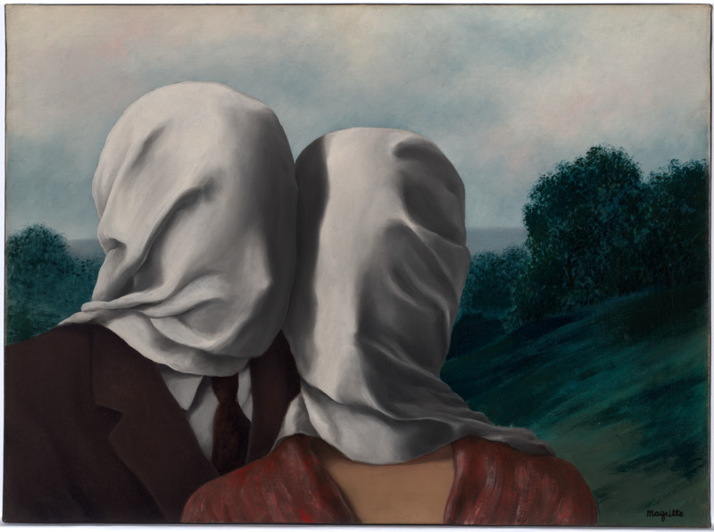

Suffocating Matrimony

Madness. Hysteria. Delusion. Psychosis. Madness. Hysteria. Delusion…
I love my husband. He loves me back. The way our bodies interlink when we dance in intimate fashion. An ever-present murmur in my ear, his loving lips pressed into the crevices of my neck. We were made for each other, since that serendipitous day in spring I felt only the strongest connection. The wedding on the sunny coast of Ireland. It wasn’t even our wedding, but we still felt like the happiest couple in the room.
……….
It was still spring when we moved into his family’s quaint farmhouse. I loved his honesty, the way he effortlessly complimented my dress, my clothes, my smile. I relished farm life, waking to the crisp breeze, the smell of fresh, sweet flowers. Even the birth of the young lambs, a new one born every other day, was a strong reminder of the freshness of life on the farm. The idyllic flowers convinced us to have our wedding in spring.
Soon the wedding came. He was dressed in his classic too-dark, brown suit, me in a traditional white bridal gown. They claimed it was lucky to have rain on your wedding day, as we splashed in the puddles together, arms interlocked like partners at a line dance, we thought of nothing but the happiest moment of our lives. The satin and silk stitching embodying every young girl's dream in life. To get married. It was my moment, my chance at a new life. Every joyous feeling I ever had about my husband, this marriage, my freedom, was encapsulated in the fabric of this wedding dress.
The wedding came and went in a flash. Summer brought our honeymoon in the sundrenched city of love, Paris. We had booked a charming room behind the Eiffel Tower, and we were excited; living in Ireland we had heard so much about French summers. However, things were different for us. The temperature had continued to rise past the expected maximum. 20, 30, 40, steadily rising. We were forced to stay inside our room for three days, the heat was unbearable. My husband never got along with the heat. He began to sweat like a pig, and by the end of the week you could have filled the Mariana Trench two times over with his purulent leakage. He had booked a dinner in the heart of Paris. His clammy, sweaty hands dialled the phone. But I didn’t go - I told him I was feeling a bit under the weather, that he should go by himself. I just couldn’t imagine his perspiring hands, grabbing at our shared dinners, or his dry lips as they awkwardly fumbled for my neck. Instead, I decided to stay in the room. That was just as depressing, as the filthy stench of his perspiration seemed to permeate the room. I was left sobbing, a disgusted wreck.
We returned to Ireland, the Autumn weather a sharp contrast from the sweltering French summer. A stale silence had wrenched its way into my house, replacing the joyous laughter that had once filled the halls. The paint on the walls was beginning to chip away. Husband and I had started to drift apart. He began sleeping in the guest bedroom, complaining that I move around too much at night. A solemn feeling traipsed through the house, following us through each room, like a dark shadow we couldn't escape. We began clearing out the study, unable to decide whether we paint it pink or light blue, a candle of hope towards our reconciliation still flickered within my soul. This only made things worse, as our distaste for each other leapt from within our hearts, making us more distant. I found my wedding dress when rifling through some boxes, and the icy grip of dread tightened around my soul. When I tried it on, a mocking sneer overtook Husband’s face. I don’t think he liked it. It was a harsh reminder that the very fabric that had freed me from girlhood, was only a suffocating sense of what could have been. A marriage that had grown stifling with time. The candle within me lost its flame, smothered by the very thing that had once fuelled it.
The Irish cold chills me to the bone, layers of clothing become like paper as they are ripped apart, left meaningless by the frigid weather. However, this still felt like a warm hug compared to the biting frost that drew breath from my lungs whenever Husband spoke. His bitter tone, loud and obnoxious, was the worst chill of the winter. Husband’s rough hands throwing me around in a tussle for control, something we lost months ago. We didn’t like each other now, maybe we never did. Maybe our love was a figment of my imagination, a misconstrued opportunity for me to surpass the chains of my youth. The wedding in spring was a false memory of love. The honeymoon in Paris- the beginning of our unravelling relationship. Finally, those autumn months, spent arguing and fighting. I was forced to move out, as the house began to decompose. The walls felt like they were crumbling apart, bringing the roof down with it. Our dream of having a family was gone, as the study fell to disarray. The candle’s flame had finally been extinguished by winter’s relentless grip.
……….
Sanity. Calmness. Reality. Rational. Sanity. Calmness. Reality…
I hate Husband. He hates me too. The way our bodies are tossed around when we fight. His obnoxious voice yelling all the time, while his burly hands grasp at my neck. I wish I knew from the beginning that I’d hate him. I remember when I met him. It wasn’t even our wedding, and yet as the bride’s dress fluttered across the dance floor, I saw the fabric begin to tighten around her neck as she gasped for breath. I hope her flame burns brighter than mine.

Bibliography:
Magritte R (1928) Les Amants [painting], National Gallery of Australia, Canberra.

