25.9.2014

When 13 met 14 – Creative Submission for UC
Amelia Green (0411859)/Year 12/St Francis Xavier College Florey

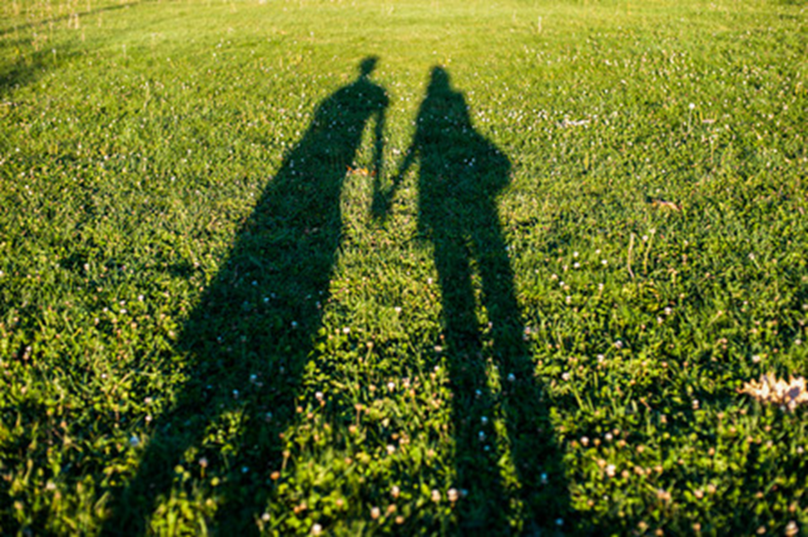
When 13 liked 14.
When 13 liked 14, it was spring. They were entranced with the butterflies newly bloomed from their cocoon. Pinkies shyly intertwined, walking through the garden of unravelling flowers. They liked the innocence and excitement that spring brought, how everything was fresh and new after years of winters spent alone. When 13 liked 14 they were a fragile flower in the spring field of emerald clovers, an abundance of chance and fortune for the flower to grow and pollinate, but an unfortunate chance for the petals to drop, the stem to snap, and the flower to be lost amongst the clovers. When 13 liked 14, the flower stood precariously towards the sun; everything was unknown and frightful, but they stood, nonetheless. The stem and leaves grew greener, and the delicate petals developed in colour. When 13 liked 14 the sun shone soft and the birds sung sweet, they walked amongst the clovers as they have done all throughout spring, and they whispered sweets songs in each other’s ears just as the birds did before them. When 13 liked 14 it was as sweet as spring.
When 14 liked 15, it was autumn. They had aged like the apple cider from the homely market stall. They embraced the soft breeze that ushered the crisp leaves along the pavement where they walked, admiring the rows of trees, whom were preparing for a season of rest. When 14 liked 15 they strolled past the carefully raked pile of leaves that sat on their familiar field of clovers, making a conscious decision not to leap into the leaves together, but rather look onward towards the fawn-coloured path they felt content walking. They kept their hands intertwined together as the towering trees loomed endlessly, with a rainbow of umber leaves forming a ceiling that let through pristine golden sunrays that warmed their faces. When 14 liked 15 they stepped upon the leaves which crunched under their footsteps as the path twisted and turned ahead of them, the hike being unknown made their hands tighten, but linked, nonetheless. They lived the season of the dust, forever sown to the horizon and the auburn sky, the sun always near its peak, but the moon too almost whole. They were fighting the coming of the frosted clovers, curled into the blankets with a head on their chest, listening to the heartbeat that would continue to beat through every season, beating for every storm, bloom and every fall of a leaf, their hearts beat for each other. When 14 liked 15 they underwent transformation as meaningful as the autumn leaves, which meant unfolding until only the lumber remained, leaving space on the branches for growth until the chill in air fades, and when the flowers induced their buds. They grew and matured alongside the flora they’ve known since spring, and under all circumstances will always bloom again in summer, regardless of how the storm stirs. When 14 liked 15 it was as ageing as autumn.
When 15 liked 16, it was winter. They stood drenched from the volley of hail with the absence of shelter, with rosy droplet-soaked cheeks they inched through the rain for what seemed to be countless cycles of the storm. When 15 liked 16 they held each other in soft blankets taking refuge from the cold without uttering a word. They liked to console each other as palms married misty cheeks, and smiles became demanding work to their faces, they had the warmth of each other but still never had known this sort of cold. When 15 liked 16 the storm battled against the sea, they were but two elements of the same, fighting for the right of the horizon that they didn’t know they were meant to share. They fought as waves collided and the storm cracked, despite the force, straying droplets from sea spray and rain mist met gently. Regardless of the storm, they reunited, understanding ultimately, they were one. When 15 liked 16 they liked the reassurance after the season of shivers and chattering teeth, where their hands were loosely sewn together, and easy smiles became a surprise. They liked the snowflakes that fell to then melt on the warmth of their cheeks, lone droplets wiped away from the glide of a thumb. They knew it was still the season when the snow covered the clovers they’d walked before, like a blanket waiting to be borne in times of desired comfort and warmth. When 15 liked 16 it was as weary as winter.
When 16 liked 17, it was summer. They felt a spark from a bonfire worthy of midsummer, a spark they felt in their beloved field of clovers, but in it more passion and awe. They ran across the flaxen sand, feeling every speck between their toes, feeling the sand soften under their heals as they neared the folding waves. When 16 liked 17 they joined arms watching only what was ahead of them, the footprints behind didn’t matter whether they were still embedded or swept away, as long as there’s a plain slate of sand ahead. When 16 liked 17 they finally felt the sun, uncovered and its rays strong; there would always be reminiscence of all the seasons, and the paths they walked, and in their bittersweet field of clovers. When 16 liked 17, they settled upon their sand dusted patterned towels, a head rested upon a shoulder gazing towards the sun, finally in its peak, finally bright after winter nights and chill autumns, shining like spring upon the leaves of the tree they grew from hard work and understanding. They sat until the sun set and both hands met on the clock’s face, fireworks boomed, and in the sparks, they saw affection and devotion right next to the shape of two bodies wrapped in an embrace, never seeing the end although the sky became clear. When 16 liked 17 It was as significant as summer.
When 17 liked 18, all the seasons had ebbed and flowed. Uneasy storms and sun rays alike, 17 liked 18. They loved butterfly kisses from spring and still walks from autumn. They loved the mornings after those winter nights of thunder, where the sun shone through the window upon each other’s eyes, reflecting moments from summer days spent in a calm ocean. When 17 liked 18 they promised endless more seasons, whether they be chills upon frosted grass or where the sun toasted the sand. With the promise of more seasons 17 no longer liked 18, 17 loved 18.

