Kids Toy
Design Project Folio
BY LAURA HOUGHTON
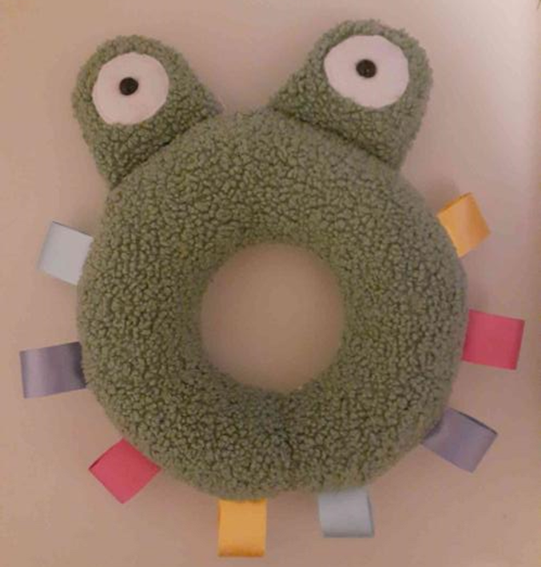

This Folio relates to the creation of my kids toy, from the initial idea generation of deciding to actually make this specific design and the physical creation. This was for one of my Senior Assessments.
Project Proposal and Project Management

Identification and Exploration of the Need

The Identified Need

Tactile development is very important in young children development. Integrated learning strategies (2016) states that “The touch sense develops… at around 16 weeks and continues to develop.” As well as “Tactile learning and touch is essential for a child’s growth in physical abilities, cognitive and language skills, and even social and emotional development.” Despite the necessity for tactile development in young children there is a lack of stimulation in young children. Joseph Doyle, Pascaline Dupas and Karen Macours (2020) state that “Simple activities such as playing, reading, and singing with children are core components of early childhood stimulation (ECS). ECS can improve young children’s ability to think, communicate, and connect with others. However, many children are not getting enough stimulation during this critical time.” To address the importance of this issue I propose to design a young children’s toy that incorporates a range of tactiles to help stimulate young children.
Initial Research

Question: What are the most popular types of baby toys?

Research and Outcome:
After the initial research of these sites:
- https://www.verywellfamily.com/best-infant-toys-4165642
- https://www.mumsmakelists.com/25-essential-toys-for-babies/
- https://www.naeyc.org/resources/topics/play/toys
- https://www.healthline.com/health/baby/best-baby-toys

I learned that there is not one singular type of popular baby toy, they all vary in size and function though, most if the toys ages at younger children all involve the use of your hands and the involvement of different tactiles and textured surfaces.
Examples of favoured items include;

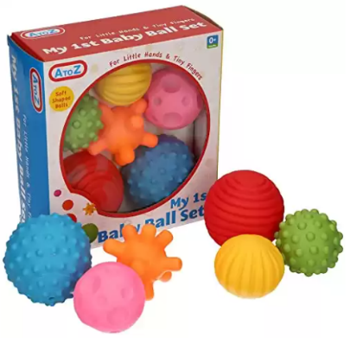
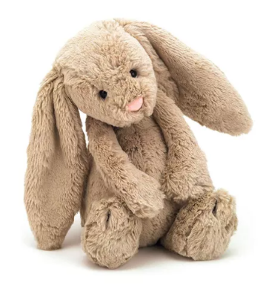
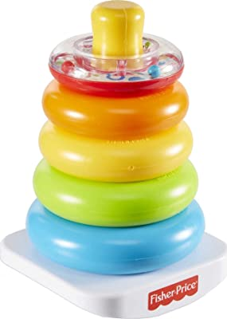
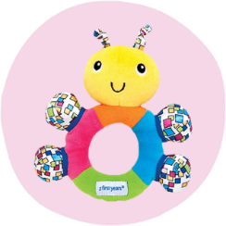
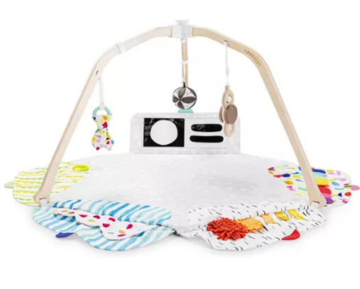
Common features include:
- Varying tactiles
- Circles and circular shapes
- Fluffy material
- Use the involvement of hands.
- Can be travelled with (excluding mat)

Research conducted at Baby Bunting Wagga:
I decided to go to Baby Bunting to see what toys are readily available in stores.

Image of Toy | Pro’s/Likes | Con’s/Dislikes
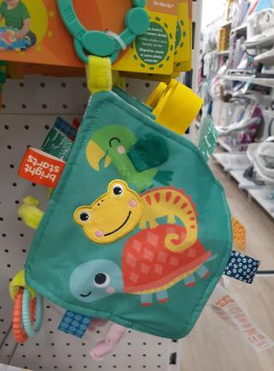 | - I like how the Toys are filled with crinkle fabric  - flat (take up less space)  - Use of bright colours  - Clip to attach to bag/stroller | - Could be harder for babies to pick up (flat)  - Doesn’t involve many tactiles
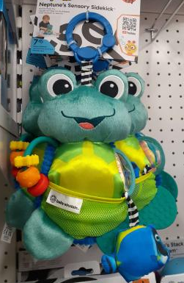 | - Gender neutral toy  - Easily recognisable animal  - Used a range of tactiles and materials  - Clip to attack to bag/stroller | - Doesn’t involve many tactiles
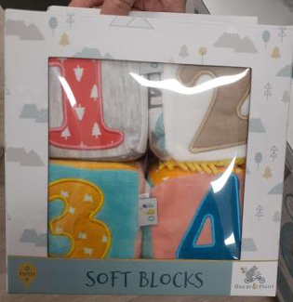 | - Encouraging learning and number recognition  - Gender neutral design | - More bland colouring  - Dosn’t involve many tactiles
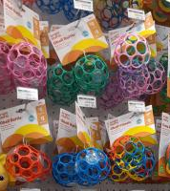 | - Use of hard/soft plastics  - Can go in mouths  - Easy to grab (with varying hole sizes) | - Use of hard/soft plastics  - Doesn’t involve varying tactiles  - seems kinda sad to play with
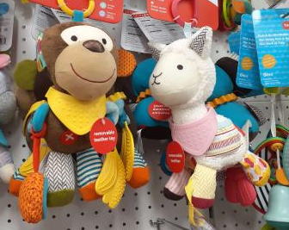 | - Variety of tactiles  - Gender neutral toys  - Use of bright colours  - Defined animals shapes | - The use of colour brown  - The mouths  - Assortment of colours are to much
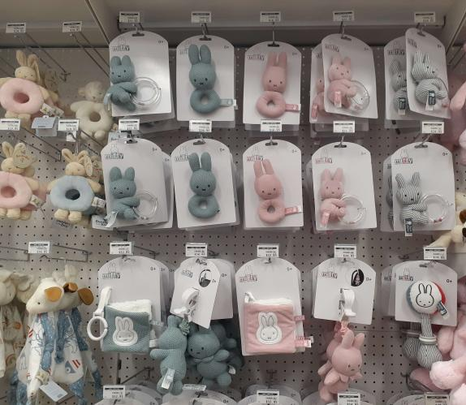 | - Simple design | - Simple design  - Boring  - Not inviting
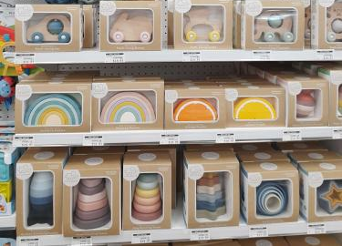 | - I like the use of wood and hard plastics  - Simplistic design  - Colours are more neutral which I like but should be more vibrant for babies. | - The price of these ranged around $25-$30 for something with a less complicated look.
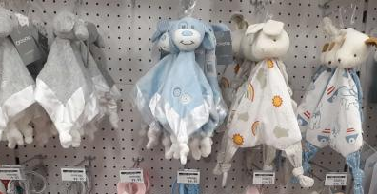 | - Like the shape of the toys | - Colours are a bit bland

Design Brief

To design and construct a child’s toy suitable for children over 3 months old, the child’s toy is to be made using a range of varying tactiles and be designed after and easily recognisable animal.
Target Market

My age demographic for my MDP kids toy is ages 3 months+, the toy is not marketed at any specific gender. Though the toy is also needed to also appeal to adults who would be buying the product. This can be through bright colours or a unique design. The product should be able to be bought by just about all parents/caregivers of all income ranges.

Areas of Investigation

What is to be investigated:

For the design of my kids toy I intend to research the following:
- What are the most popular tactiles amongst babies and very young children.
- What materials are safe for babies to put in their mouths and play with?
- Can babies and young children play with 3D printed or PLA products?
- Dose the interaction of different tactiles effect childhood development in any way?
- Do bright colours stimulate children more than dull colours?

How you will investigate it:

To find conclusions to these questions I will be mostly investigating the questions and topics through research on google. Through the use of websites on the topic as well as scholarly articles and papers. Mt the information will be cited from mostly secondary sources even the scholarly articles. I will also conduct some research through looking into shops and catalogues.
Justification of why this factor is important and how finding out about it will impact on the success of your MDP

Almost all of the intended research questions are necessary for the development of my design portfolio. The most important question is “What are the most popular tactiles amongst babies and very young children.” And “What materials are safe for babies to put in their mouths and play with?”. The research into these questions will heavily help how I design my kids toy. Without researching these questions my kids toy would not be as well rounded. Though all the other intended things to investigate are important to my kids toy, the research of them will not detriment the progress of the MDP. Though most of the things to be investigated won’t effect my design the intention for the ‘Kids Toy’ could vary. Though through the correct research investigating these topic will allow me to develop a more in-depth kids toy design.
Parameters of Design

Time:
The available time to complete the kids toy and design portfolio is; 11 weeks including 2 weeks school holidays. I was allowed an extra 2 week extension. After creating an analysis of available time I know that there is a max of 3.5 hours on weekdays, a max of 8.5 hours on Saturday and a max of 9.5 hours on Sunday.

Cost/budget:
The cost of the design project comes down to how much I am willing to pay for materials. The overall production cost of producing one item should be less then the expected/estimate sale price and make for the product. I have a budget limit of $40 for the whole design project.

Skills and knowledge:
Skills and knowledge of teachers at school such as Mr Teakel and Mrs Richie as well as fellow classmates and friends. As well as the knowledge of my mum (artist)

Materials:
There is a variety of material I could use for the design project. There is a limit of materials supplies at school, these materials include; simple fabrics, range of wood types wood, metal, PLA and other 3D printing materials, cardboard, paper and plastic. You can use a range of other materials as long as they are self-supplied and purchased with your own money.

Machines:
There are a number of tools and machines available at school to be used to create the design project. These include; a sewing machine, 3D printers, laser cutters. To make it easier to complete the design project you can use things available at home.

Size:
The kids toy design(s) are required to fit inside a 300mm/300mm/300mm box, this is roughly the size of a milk crate. The design can be made up of multiple parts and pieces. The measurement requirements for parameters cannot be adjusted e.g. being changed to 500mm/200mm/200mm. The size must be 300mm/300mm/300mm.

Criteria to Evaluate Success

Criteria Functional | Analysis | Impact
To be no larger then 30cm/30cm/30cm | This is an essential criteria for the MDP as it is a key feature of the assessment task instructions. Though most kids noys should not take much more area. | By not achieving this this criteria, there is a limitation on how well you will go in the marking of the assessment.
To easily be able to be held by a young child/toddler | This is an essential factor as my design brief is a toy for younger children and if the toy is not easily able to be held, is cannot easily function. | This allows the child to activity play with the toy in their own way and not be restricted by the size of the toy.
To be made of at least 3 different tactiles | My research shows how important of tactile development in children and in that sense is one of my criteria. | The impact of not achieving would create a “boring” design. There would also be no purpose for my specific toy as my intention is to make a multi tactile toy.
To be able to attach to a bag/stroller | This allows parents to take the kids toy to public spaces and allows for an extra easily toy to carry. | The impact of not achieving this is the outcome of a less multifunctional toy.

Criteria Aesthetic | Analysis | Impact
To be bright in colour | Children are more stimulated and attracted towards bright colours. This criteria should also influence the parents to purchase the kids toy due to the use of colour. | Though the kids toy is still functional without the use of bright colours it makes the toy more desirable to children and impacts the stylistic chouses for my design project.
For the desired animal design to be easily recognisable | The use of a recognisable animal in the design helps the toy stand out more in stores over toys that are plain. It also can make the toy more gender neutral if the toy is made to look like an animal not just plain colours. | This impacts this has is most likely the market sales. The use of a recognisable design help the toy be more desirable for kids to play with.

Criteria  Safety | Analysis | Impact
To be able to be washed in the washing machine. | Toddlers and young children are prone to chewing on their toys and this can make the toys dirty. Allowing the toy to be washable makes the toy last longer. And is mor time efficient then hand washing. | This criteria is more of a want then a need and will effect my design project in the way that the toy’s use. Though the toy can still function through hand washing or no washing.
For the fabric and stitching to be safely sewn in place and not fall apart safe for young children/toddlers to play with. | This criteria is for the safety of the children playing with the toy, this is to make sure that the toy’s are child safe reducing the risk of swallowing or eating parts of the toy. | Without this criteria the toy would fall apart and would contradict the purpose of the portfolio, to make a kids toy. If the toy is not safe to play with and is falling apart it isnt a kids toy.

Action, Time and Finance Plans and their Application

Analysis of Available Time
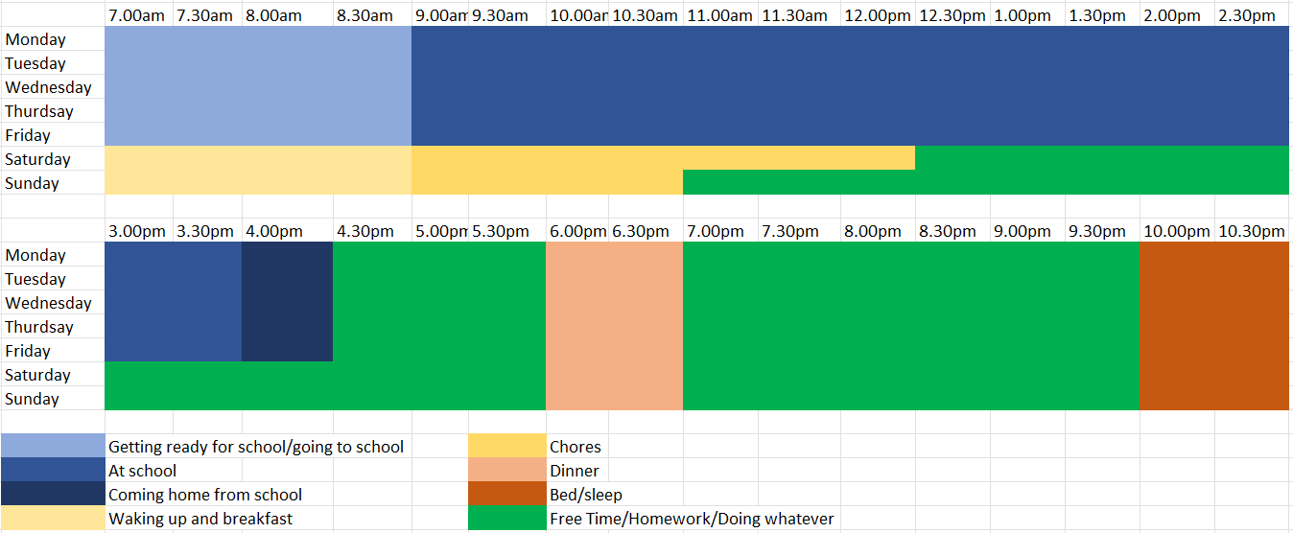
Initial Time/Action Plan

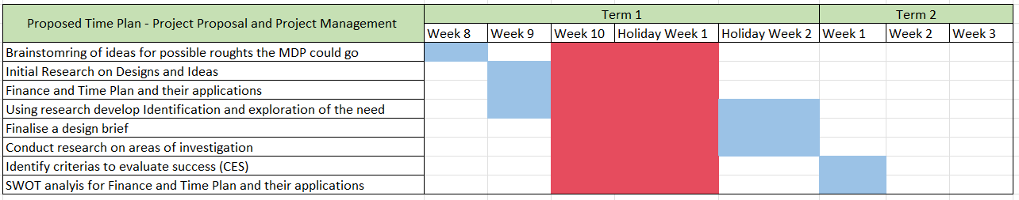
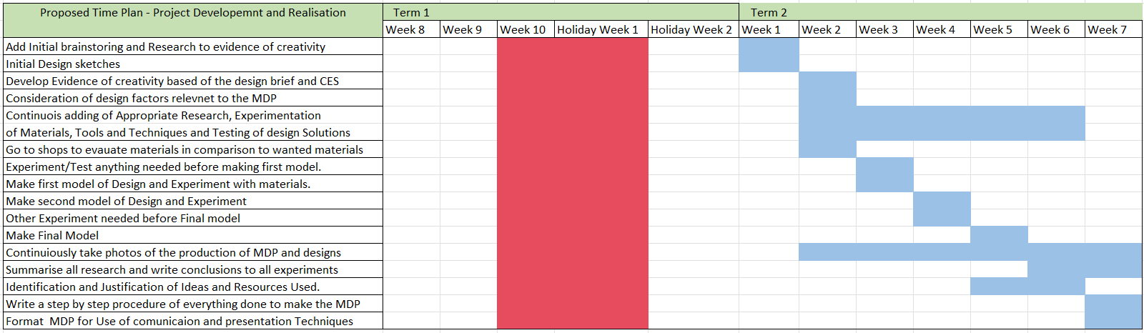

Actual Time/Action Usage

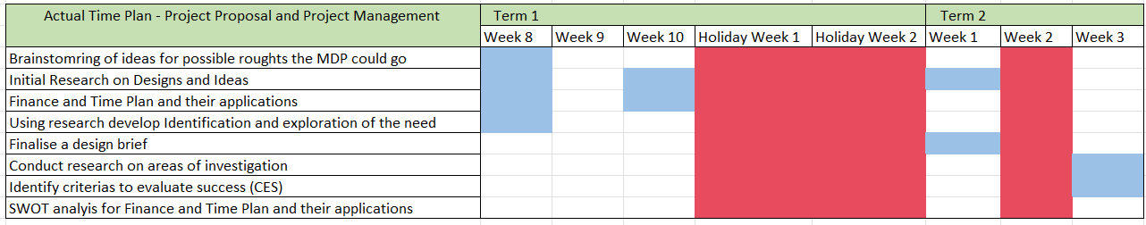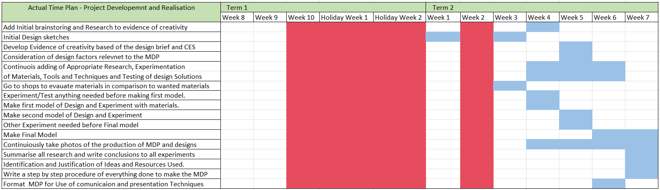

Finance Plan

Item | Supplier | Website/Researched Cost | Estimated cost | Actual Purchase Cost | Justification
Minky Dot Polar Fleece Fabric Aqua | Spotlight | $12 per metre | $6 | $10 per meter = $5 | I estimated the price for a whole meter, I purchased 0.5m as well as the item being on sale and having a VIP discount
White Felt Sheet A4 | Spotlight | $2.25 each | $2.25 | $1.75 | I estimated the cost based on the RRP price not knowing id receive a VIP discount
Double-Sided Satin Ribbon Gold (25mm) wide | Spotlight | $1.50 per metre | $2.50 per metre | $2.50 per meter = $1.25 | The researched price was for VIP pricing though I only got charged the RRP
Berisfords Double-Sided Satin Ribbon Lupin (25 mm) | Spotlight | $1.50 per meter | $1.50 per meter | $2.50 per meter = $1.25 | The researched price was for VIP pricing though I only got charged the RRP
Berisfords Grosgrain Ribbon Sky (25 mm) | Spotlight | $2.40 per meter | $2.40 per meter | $4 per meter = $2 | The researched price was for VIP pricing though I only got charged the RRP
Berisfords Grosgrain Ribbon pink (25 mm) | Spotlight | $2.40 per meter | $2.40 per meter | $4 per meter = $2 | The researched price was for VIP pricing though I only got charged the RRP

Project Development & Realisation

Evidence of Creativity
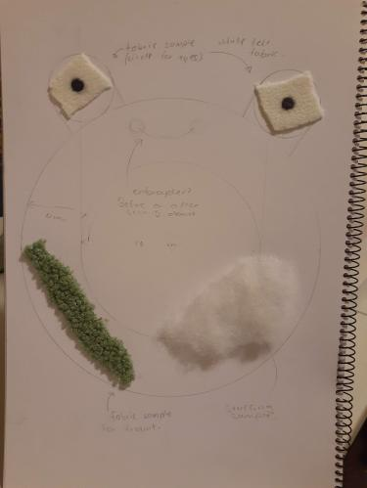
Initial design sketches
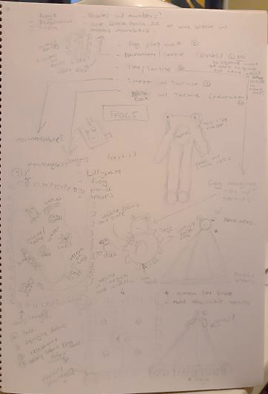
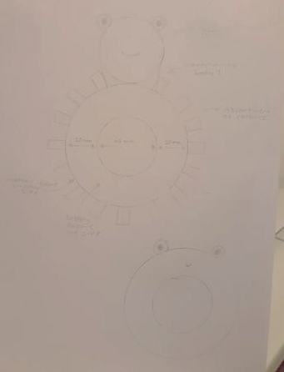

Exploration of Existing Ideas
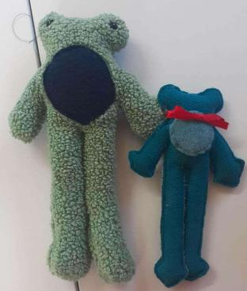
Plus:

I like the fabric texture and aesthetic choices for Gilbert. As well as the use of circles within the designs. Additionally the I like the idea of frogs and the use of safety eyes.

Minus:

The patch I the body is too close to the edge of the design. The hand sewn design of Gary’s patch

I can see the pencil lines drawn on Gary.

Interesting:
I never see many/any toys that look anything like this, especially being frog themed Additionally, there is a lack of frog themed toys around.
Figure 1- Gilbert (Left) and Gary (Right)
Consideration of Design Factors Relevant to the Major Design Project

Factor Affecting Design | Importance
Function | Function is one of the most important factors for my design project. If the toy does not function, then it would not be a very successful or functional toy.
Aesthetics | Aesthetic is the next most important factor to me as I would always look at a products look before its cost and quality. When a product looks really nice it usually is made with high quality especially with kid’s toys. This is very important to me as I do want my toy to look very pleasing to children and parents.
Finance | Finance is an important factor in design though you want the design to be low cost the overall sale price can be raised if the product is of high quality, functions as intended and is aesthetically pleasing. Though keeping the production cost of the product is important to me.
Safety | As this toy is targeted towards children I want to make sure my toy is very safe. Making sure the toy does not have any dangerous parts in it as well as not falling apart, this connected to quality. The toy must be safe for children.
Quality | Quality is one of the important aspects of a toy if the toy is made with poor quality and wears down easily this can affects the toys function and safety. It must be durable and last for a long time.

Appropriate Research and Experimentation of Materials, Tools and Techniques and Testing of design Solutions

Research
Answer to initial questions:

What are the most popular tactiles amongst babies and very young children.
Resources:
- https://www.wonderbaby.org/articles/tactile-input
- https://mommyhood101.com/best-sensory-toys
- https://www.littlelocals.qld.edu.au/texture-exploration/

What materials are safe for babies to put in their mouths and play with?
Resources:
https://dontplaywiththat.com/blogs/news/household-items-that-are-safe-for-babies-to-put-in-their-mouths
https://kidshealth.org/en/parents/safetoys-young.html
Can babies and young children play with 3D printed or PLA products?
Resources:
https://rb.gy/6tndu
https://www.quora.com/Can-you-make-3D-prints-that-are-safe-for-babies-to-play-with
https://www.techagekids.com/2013/06/is-3d-printing-safe-for-kids.html

Dose the interaction of different tactiles effect childhood development in any way?
Resources:
- https://wellements.com/blogs/the-well/why-its-important-to-expose-your-baby-to-different-types-of-stimuli
- https://ilslearningcorner.com/2016-05-tactile-learning-how-your-child-learns-through-touch-and-their-tactile-system/
- https://rb.gy/h0yqa
- https://gettinlifedunn.com/the-benefits-of-tactile-learning-for-kids/
- https://www.wgu.edu/blog/what-tactile-learning2008.html#close
- https://www.povertyactionlab.org/policy-insight/encouraging-early-childhood-stimulation-parents-and-caregivers-improve-child#:~:text=Simple%20activities%20such%20as%20playing,%5B1%5D%5B4%5D.
- https://readykids.com.au/sensory-toys-for-toddlers/

Do bright colours stimulate children more than dull colours?
Resources:
- https://shorturl.at/qzK58
- https://sciencing.com/do-bright-colors-appeal-kids-5476948.html
- https://democa.com/blogs/parents-blog/bright-colors-vs-muted- colors-how-it-affects-your-little-one

Research during the creation of the project

- Websites/YouTube on how to make a donut.
- How to fix clumping of thread in a brother sewing machine
- How to flip donut un right way
- How to sew thick fabric

Testing/Experimentation
TEST 1: Ways of hand sewing to patched of fabric
Research Prior to test:

- https://www.youtube.com/watch?v=hGwT5yUn4bY
- https://www.youtube.com/watch?v=c2B_fgEGMlM
- https://www.youtube.com/watch?v=WbE5hXt27uU
- https://www.youtube.com/watch?v=fWlDFDmzNp0

Aim: To find out the best way to sew a patch by and onto another piece of fabric.

Tools and Materials:
- Thread and needle
- White cotton
- Green fluffy fabric

Outcome and Conclusion:
started hand sewing based of my research though I did not end up completing this experiment. I did learn how to sew a ladder stich in the process. Overall, I decided that his method of hand sewing a ‘patch’ or piece of material was to much effort and to tedious. I will in turn sew the pieces together with a sewing machine instead.

TEST 2: First test of making a donut
Method:
- Turned initial design sketches into simple pattern (body and eyes) with a 1.5cm hem.
- Cut out fabric.
- Pinned body fabric leaving a gap at the bottom to flip the fabric inside out once sewn
- Pinned white eye fabric to eye body.
- Sew eyes onto eye base and put in safety eye pins (made a test squeaker to fit into test model). (eye was basically exact size of squeaker)
- Made an eye. Realised eye was way to short so I recut eye fabric with about 3-4cm hem (guestimeated had no pattern)
- Re cut out fabric for eye base and white eyes
- Sewed on white eyes and pinned eyes. (Hem needs to be wider, fabric stayed together but not 100% safe if played with, stich was very close to edge.)
- Sewed centre of donut body.
- Pinned in eyes and tags onto body.
- Sewed edge of body leaving a gap at bottom to turn inside out.
- Could not turn it inside out.
- unpicked outside of donut to untwist donut, reused fabric to make base same size.

Researched other ways to sew a donut:
https://www.youtube.com/watch?v=Gpl3Hv0eTgw

I followed this tutorial to see if I could fix my issue with the flipping inside out of my donut.
- Cut out 1/5th of the original pattern
- Pinned new fabric body (donut)
- sewed centre together then outside (w/ one tag to test)
- Flipped inside out.
- Did not sew join closed as it was a test.

TEST 3: Remaking the last donut bigger and better
Method:
- Made pattern bigger
- Cut fabric
- Pinned base
- Used previously unused eyes made and stuffed them.
- Sewed centre donut body
- Pinned another tag and eyes (pinned eyes through both layers of fabric (was hard and bent a few pins)
- Sewed outside of donut
- Flipped in the right way and stuffed (did not sew close as it was a test)

TEST 4: Remaking the last donut with some different techniques
Method:
- Used same pattern for body
- Pinned and sewed inside of body
- Liked the eye size on Susan though there was basically no hem on the inside, Made new actual patter for eyes with a one cm hem around original eye pattern.
- Cut fabric, cut white eye fabric
- Pinned and sew eyed together and added eye pins.
- Realised it needed a longer base, made the same pattern with a longer base.
- Recut fabric for eyes.
- Made the eyes with eye pins. (used a different colour for safety eyes to see how they looked)
- Trying a different method of sewing in the eyes to the body as seen in the research for making the lily pads/crinkle toys. (Worked out better)

https://www.youtube.com/watch?v=-Sfwqqb2zrg
https://www.youtube.com/watch?v=vU1vQW5oIks

In combination of these videos I found a better way to sew the eyes onto the base of the donut.

- I zig-zag stitched the eyes onto the base before covering them and sewing around the whole donut closing it.

Applications of Conclusions

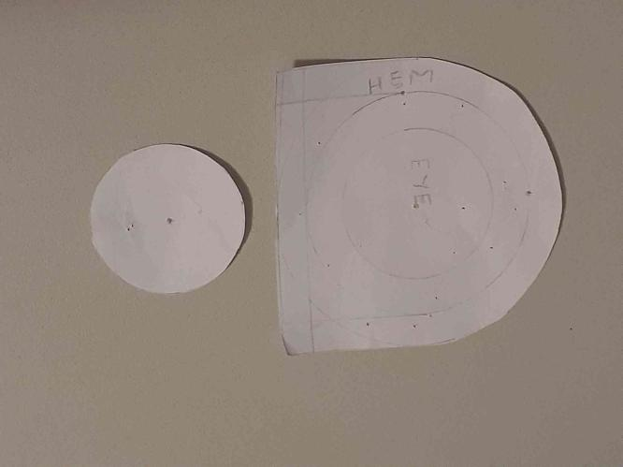
Final Patterns:
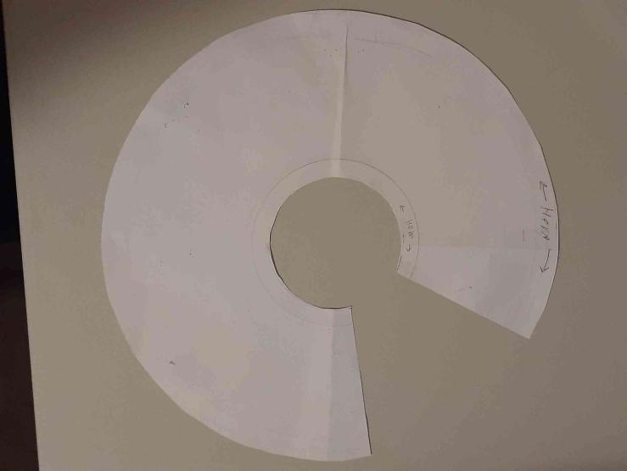
Identification and justification of Ideas and Resources Used

Identification of Idea | Use | Justification
YouTube Videos and Websites | Allowing me to be able to learn and research about topics and problems facing my design. As well as skills and required to complete the design. Allows me to research other topics and queries present in the development of my design. | Allowed me to make my portfolio to a higher standard thought the use of research for information as well as research when encountering problems in my design.
Prototypes | To show the development of my design process, to allow me help analyse the issues in the design and fix them. | These allow me to see a physical representation of my design ideas and visualise them in a way where I can make simple changes to improve their function and design to fit my criteria.

Identification of Resources | Use | Justification
People
Class Teacher(s) | Can respond to questions I had and help guide me on way to make and design things. Taught skills and information relevant to the design project. | Getting guidance and advice from teachers helped me understand the criteria of my portfolio in more depth. Teaching me way of doing stuff and providing details in problems in my design.
Peers | Assisted me in conducting idea generation and providing helpful feedback. | My classmates provided additional support aside from teachers, providing truthful feedback and input in the creation of the design.
Mother | To help assist in the generation of ideas and assisting in creating models, providing feedback and help fix errors and issues in the making process. | My mothers experience with design and her natural creativity contributed to the initial development of the toy design as well as her input and assistance when facing errors and problems.
Tools
Computer | To create designs, research, organise information, communicate, draw up sketches. etc. | This was a very useful tool in the creation of my project allowing me to find current and reliable information. Allowing me to create my portfolio and access other resources.
Sewing Machine and sewing tools (Pins, fabric markers, scissors) | To create and sew designs relevant to the design project as well as testing and experimentation. | Most likely the most important tool for my design, it physically allowed me to make a quality designed toy, without spending exhausting amounts of hours hand sewing.
Other Resources
Time | To allow the creation of the project, development of experiments and research of information. | Having an sufficient amount of time to create my design project and portfolio allows me to create it to a higher standard and the best of my ability.

Evidence and Application of Practical Skills to produce a quality Product

WHAT WE ARE MAKING:
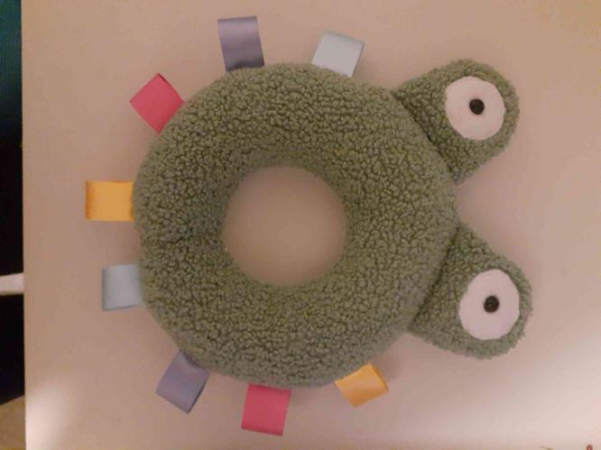

Materials:
- 2 different fabrics for the frogs body (one for the front and one for the back of the frog)
- 1 fabric for the eye (recommend using white felt)
- 2 x Safety eyes
- 2 x Squeakers
- 20cm long of 4 different coloured ribbon (or 80cm of the same ribbon)
- Stuffing
Tools:
- Sewing Machine (The thread should be white)
- Pins
- Scissors
- Needle
- Thread (Similar colour to the body of the toy or white)
Method:
- Have your patterns ready;
- Place the body patterns on top of your fabric and cut them out. Do this for each of the body fabrics.
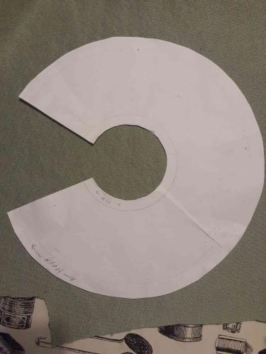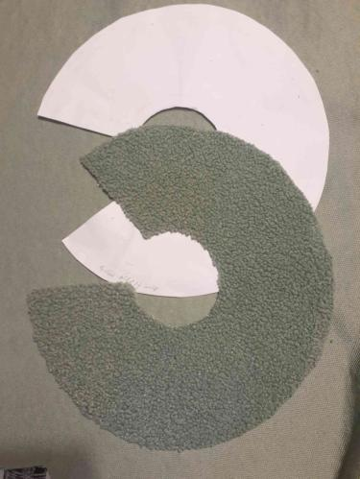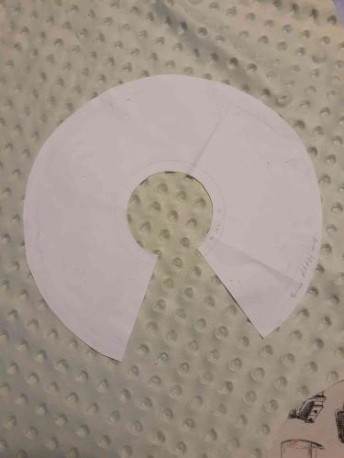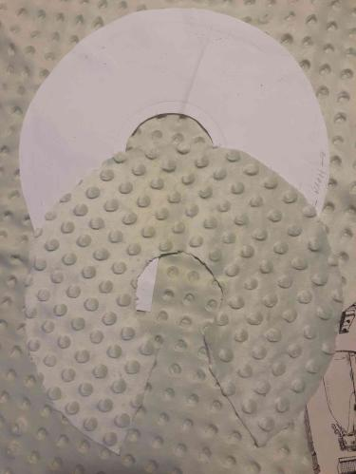
- Place the Eye pattern on the same material you wish to have for the front of the toy. Cut the pattern out four times.
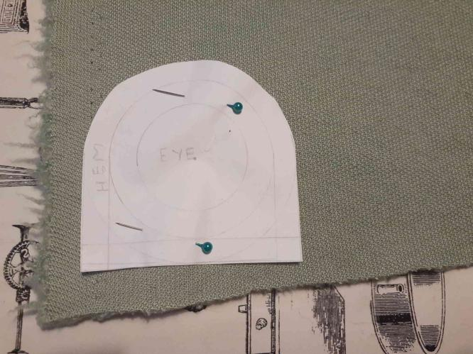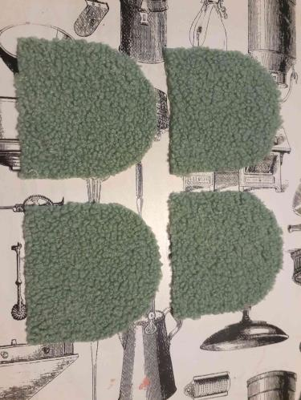
- Place the smaller eye patten on your eye fabric (white) and cut out two eyes.
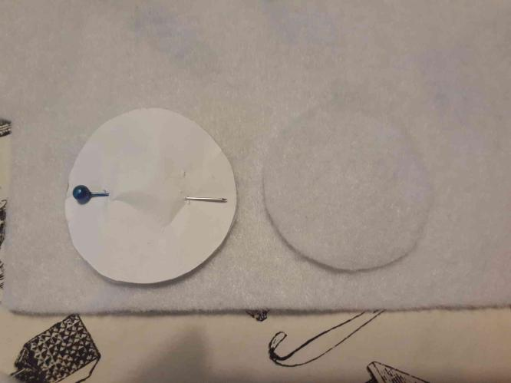
- You should now have 8 pieces of fabric cut out.
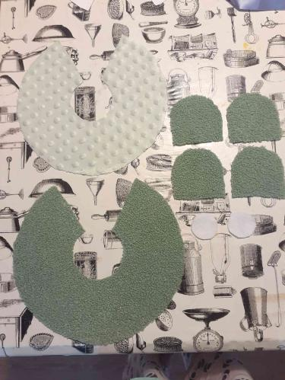

- Take the two pieces body fabric and pin them together with the sides you want to see on the outside of the toy facing together.
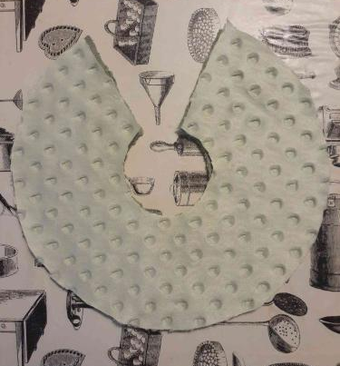
- Once they are pinned together, take them to your sewing machine and you are going to sew the inside circle. Leaving a 1.5 cm seam from the edge of the fabric. Once done set the fabric aside.
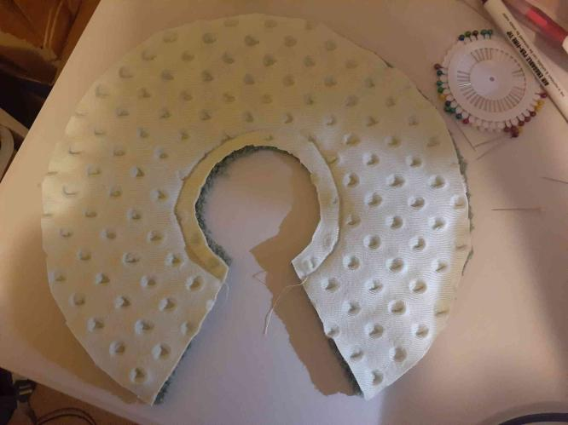
- Take two of you eye fabric pieces and pin the white circles to the centre of the fabric. I recommend marking the centre of eye fabric with a fabric marker before pinning on the white eye fabric so you can find the centre.
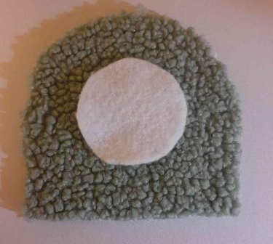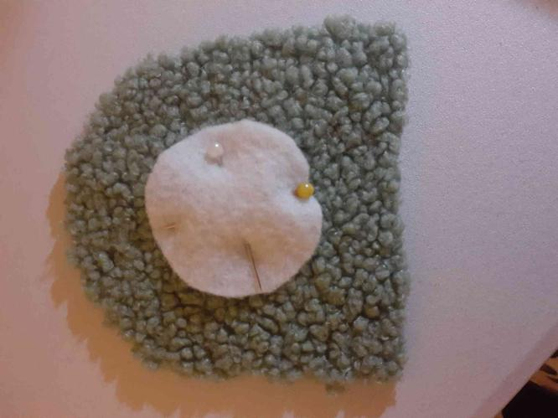

- Sew the white circles onto the eye fabric. You want to sew close to the edge of the fabric (if you are using felt the edges wont fray). Make sure to take all the pins out as you go. Do this for both eyes.
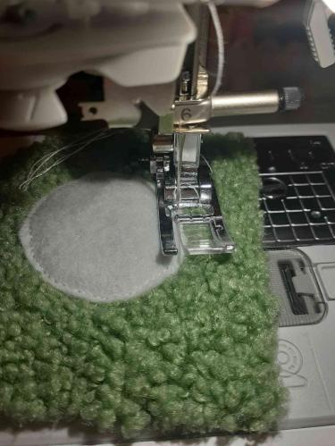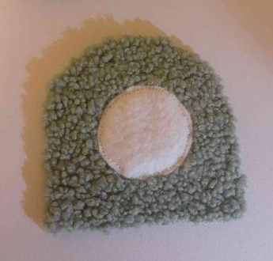
- You should have two eye bases with white circles sewn on them and two without. Pin one of each of the types of fabrics together with the two sides facing outwards together. (the face with the eyes should be toughing the outside face of the other fabric).
- Pin the fabric closed leaving an opening at the bottom (the flat side)
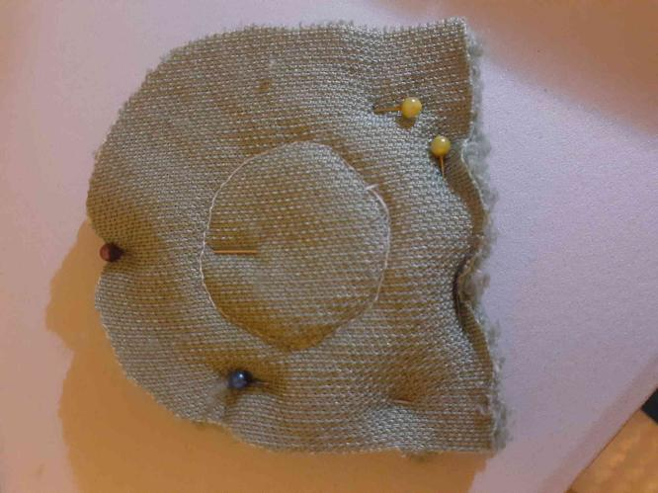
- Sew around the edge of the eyes leaving a 1cm seam from the edge of the fabric. Do this twice. Then flip the fabric inside out.
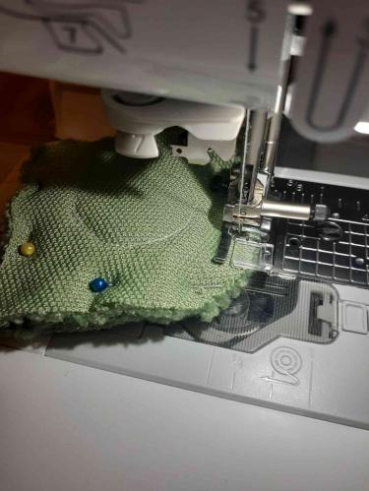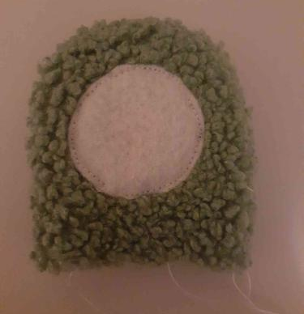
- Take your safety eyes (if you don’t have these you can draw the eyes onto the felt with a marker or fabric paint, note the marker will most likely bleed a little) and squeaker.
- You want to cut a tiny hole through the centre of the felt where you want to pin the eyes. Make sure to flip the eyes the right way so you can easily insert the safety eyes.
- Then you can place in the eyes the squeakers, you can add a little bit of stuffing to the eyes to make them firmer.
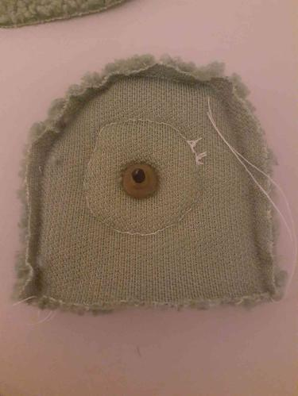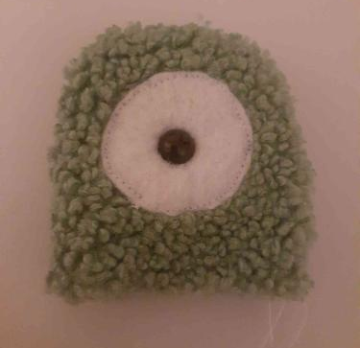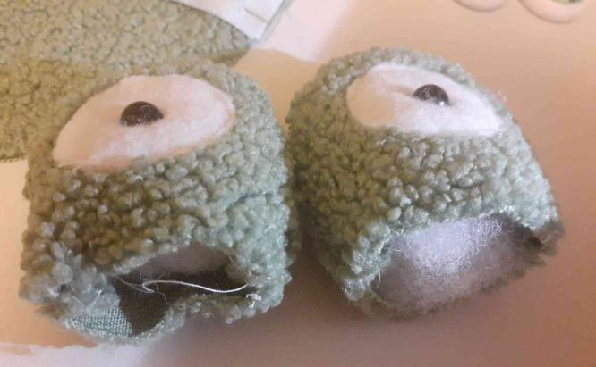
- Get back your main body piece you want to make a mark for where you want the top of the donut to be and then you want to place the eyes on either side of that mark by 1cm. You want to place the eyes between the two layers of fabric. The side of the eyes with the felt needs to be toughing the side with the safe fabric (this should be the front side of the toy) . The base of the eyes needs to be facing the outside of the main body fabric.
- Get your ribbon and cut 10cm long intervals of ribbon you want to have 8 pieces of ribbon.
- Get back your main body piece and your ribbon. You want to place and pin the ribbon in between the two layers of fabric. The ribbon should folded in half (5cm) and pinned starting from the opening edge with a 3cm gap between piece of ribbon. There should be a 1 cm gap between the last piece of ribbon on each side before the eyes. The ribbon should be sitting between the two layers of fabric but pinned from the top face of the fabric so the pins are not hidden when sewing.
- You need to pin the eyes down to the fabric, this can be a bit hard and the fabric can be thick. Then using a zig-zag stich you want to sew right along the edge of the eyes where they connect with the outside of the main body piece. Do this for both eyes. Place aside.
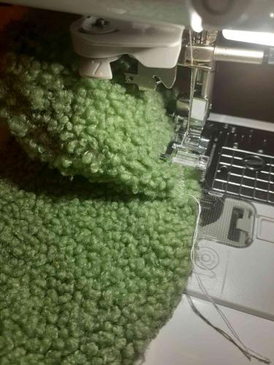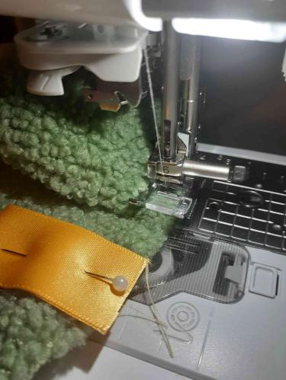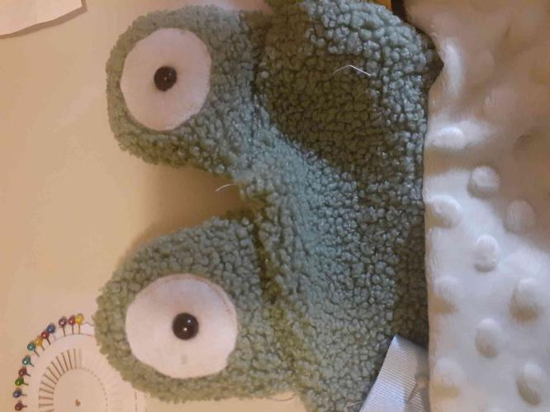
- You want to sew around the whole outside of the main body, you can put some extra pins down to keep the fabric in place. Sew around the edge with a 1.5 cm hem. Be cautious of the eyes they can be a bit hard to sew over. DON’T SEW THE TWO OPENIG ENDS CLOSED
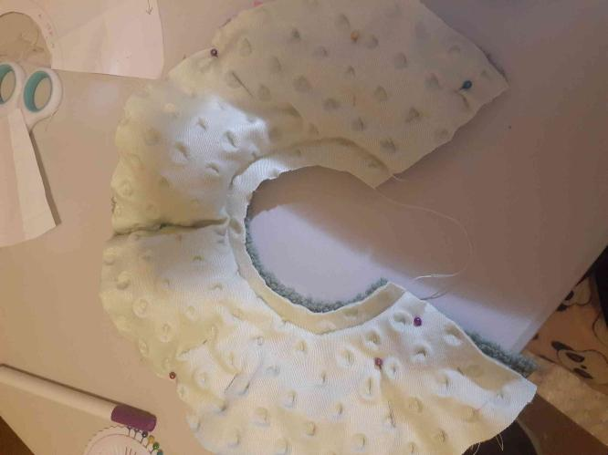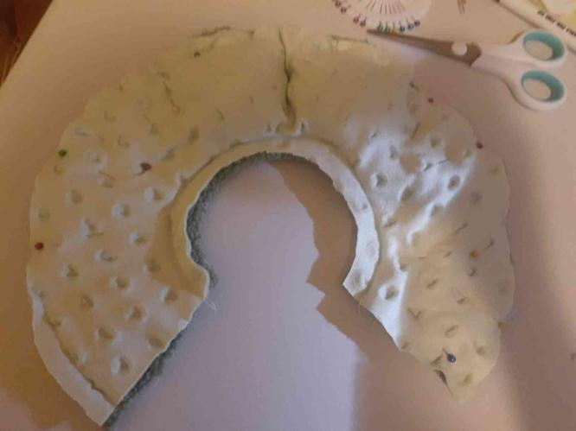
- Once that is done take one of the opening ends and start to flip it inside out, you should be able to pull the other end of the donut through the gap, note the eyes can get a little stuck.
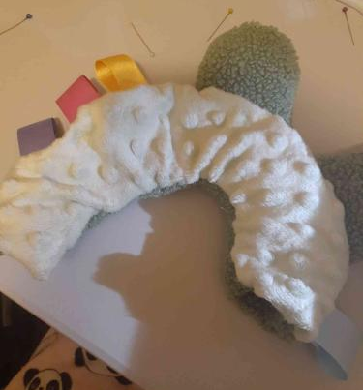
- Once done take your stuffing and stuff the donut making sure its stuffed firm. Make sure to leave a little gap next to the open edges.
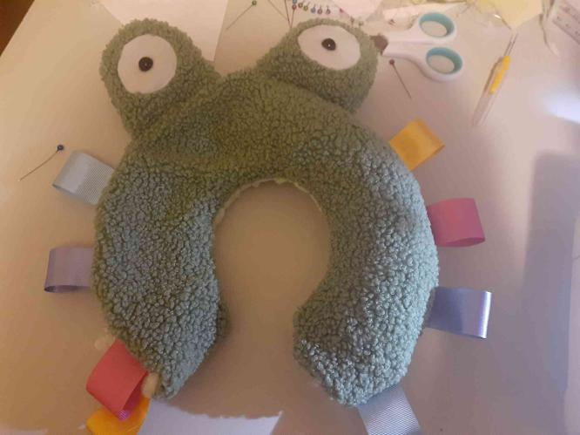
- Nest you want to thread a sewing needle with either white or a matching cotton. While pressing the two open edges together you want to use a ladder stich to sew them closed. Sew all the way around the opening until there is a small gap. This is where you can add the last bit of stuffing so the bottom of the toy is not dead. Sew the donut closed tie of the thread and now you are done.
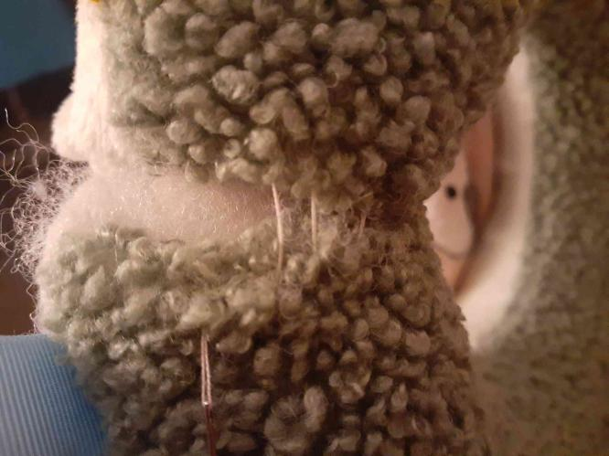
Evaluation
Recording and application of evaluation procedures throughout the design project

Design Brief
To design and construct a child’s toy suitable for children over 3 months old, the child’s toy is to be made using a range of varying tactiles and be designed after and easily recognisable animal.

Criteria of Success
Criteria Functional | Analysis | Impact
To be no larger then 30cm/30cm/30cm | This is an essential criteria for the MDP as it is a key feature of the assessment task instructions. Though most kids noys should not take much more area. | By not achieving this this criteria, there is a limitation on how well you will go in the marking of the assessment.
To easily be able to be held by a young child/toddler | This is an essential factor as my design brief is a toy for younger children and if the toy is not easily able to be held, is cannot easily function. | This allows the child to activity play with the toy in their own way and not be restricted by the size of the toy.
To be made of at least 3 different tactiles | My research shows how important of tactile development in children and in that sense is one of my criteria. | The impact of not achieving would create a “boring” design. There would also be no purpose for my specific toy as my intention is to make a multi tactile toy.
To be able to attach to a bag/stroller | This allows parents to take the kids toy to public spaces and allows for an extra easily toy to carry. | The impact of not achieving this is the outcome of a less multifunctional toy.

Criteria Aesthetic | Analysis | Impact
To be bright in colour | Children are more stimulated and attracted towards bright colours. This criteria should also influence the parents to purchase the kids toy due to the use of colour. | Though the kids toy is still functional without the use of bright colours it makes the toy more desirable to children and impacts the stylistic chouses for my design project.
For the desired animal design to be easily recognisable | The use of a recognisable animal in the design helps the toy stand out more in stores over toys that are plain. It also can make the toy more gender neutral if the toy is made to look like an animal not just plain colours. | This impacts this has is most likely the market sales. The use of a recognisable design help the toy be more desirable for kids to play with.

Criteria  Safety | Analysis | Impact
To be able to be washed in the washing machine. | Toddlers and young children are prone to chewing on their toys and this can make the toys dirty. Allowing the toy to be washable makes the toy last longer. And is mor time efficient then hand washing. | This criteria is more of a want then a need and will effect my design project in the way that the toy’s use. Though the toy can still function through hand washing or no washing.
For the fabric and stitching to be safely sewn in place and not fall apart safe for young children/toddlers to play with. | This criteria is for the safety of the children playing with the toy, this is to make sure that the toy’s are child safe reducing the risk of swallowing or eating parts of the toy. | Without this criteria the toy would fall apart and would contradict the purpose of the portfolio, to make a kids toy. If the toy is not safe to play with and is falling apart it isnt a kids toy.

Analysis and evaluation of functional and aesthetic aspects of design
Functional Criteria
Criteria | Evaluation of Criteria within the actual Project
To be no larger then 30cm/ 30cm/30cm
To easily be able to be held by a young child /toddler
To be made of at least 3 different tactiles
To be able to attach to a bag/stroller

Aesthetic Criteria
Criteria | Evaluation of Criteria within the actual Project
To be bright in colour
For the desired animal design to be easily recognisable

Safety Criteria
Criteria | Evaluation of Criteria within the actual Project
To be able to be washed in the washing machine. | I do not know if I have managed to achieve this criteria as I ran out of time and did not to test the structure of my design in the washing machine.
For the fabric and stitching to be safely sewn in place and not fall apart safe for young children/toddlers to play with. | This was achieved through the use of a sewing machine over hand stitching to create a safer toy

Relationship of the final product, system or environment to the project proposal
In the creation of my design project, I was definitely successful in the extent that I made a completed kid’s toy. Of course, there are things I wish I had done better though I am proud of my design. The toy in most aspects fills the criteria to evaluate success and it does meet my target market. I believe that my testing and experimental phase went well and really helped me in the development of my final design. I had quite a few problems with my actual sewing machine not working or getting clogged these issues delayed minor work but all got fixed. I also has a lot of problem getting the pattern for the outside of the eyes correct the hem was either to short or to long or too thin. Something that really changed along the way was not necessarily the design but the actual method of making it. After testing so much in my experiments each test was made in a slightly different way. I coped with managing time in this project to an extent. I made and followed my time plan quite well. Though over the progress of the assessment there were lots of barriers effecting my time to work on the assessment from illness mostly to procrastination and other unexpected activities. Something that I think was quite successful was the creation of the eyes in the final model they turned out a lot cleaner than the past ones. As well as the adding of ribbons from the beginning I found a clear way to sew them on and kept the same method the whole way through. Something that I would change though if I were to make it again would be the obviously my usage of time but also the development of more design ideas and hope to add more parts to the toy. Overall I am proud of my design and believe it was completed to a good standard.

