“The Journey”
This composition was inspired by whimsical nature, magic, and dreams. I wanted to create a piece where the viewer’s eyes could travel along the drawing and see the various elements within the artwork. “The Journey” represents a dreamlike scenery, where the figure in the boat has embarked on a journey to a land away from reality.
The signs on the tree point to various directions and magical lands, one of those signs I decided to keep blank. This is because I wanted to allow the viewer to choose where they wanted to travel on this journey. On the left of the drawing is a path leading to the unknown.
I decided to include Michael Jackson as the figure in the boat. Through media MJ was depicted as a crazy, eccentric person. Often being chased by media, and having news outlets twisting stories to appeal to their audiences. In my artwork Michael is shown to be escaping this reality and traveling to magical places. Adding Michael to my piece resonates with me as I enjoy his music and find his story interesting.
To create this piece I used soft pastel pencils, and Clairefontaine Pastelmat pastel paper.
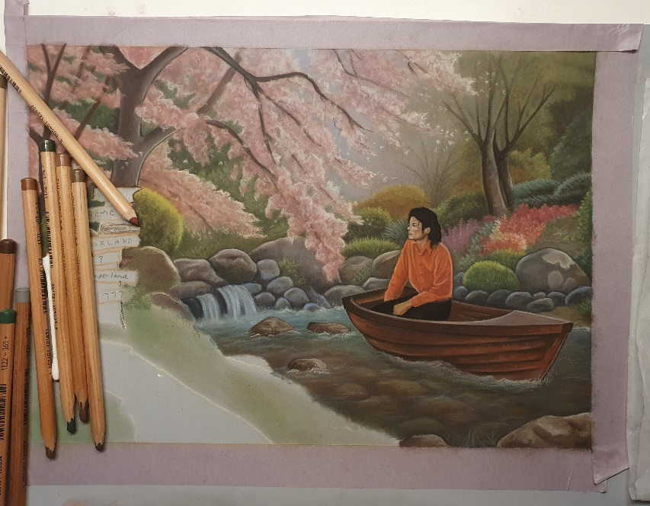
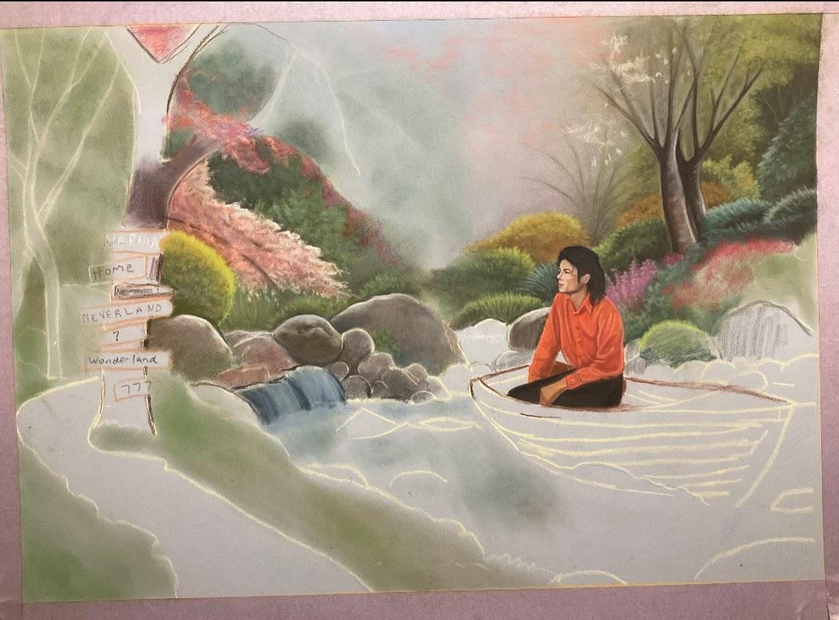
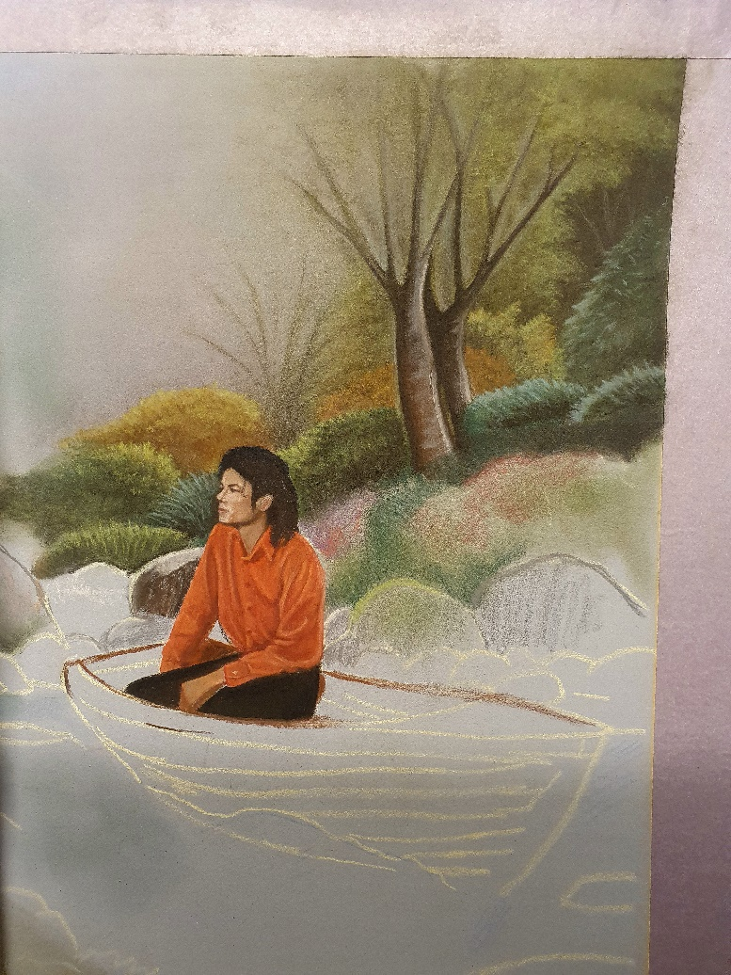
Progression Photos:
Close up images and final composition:
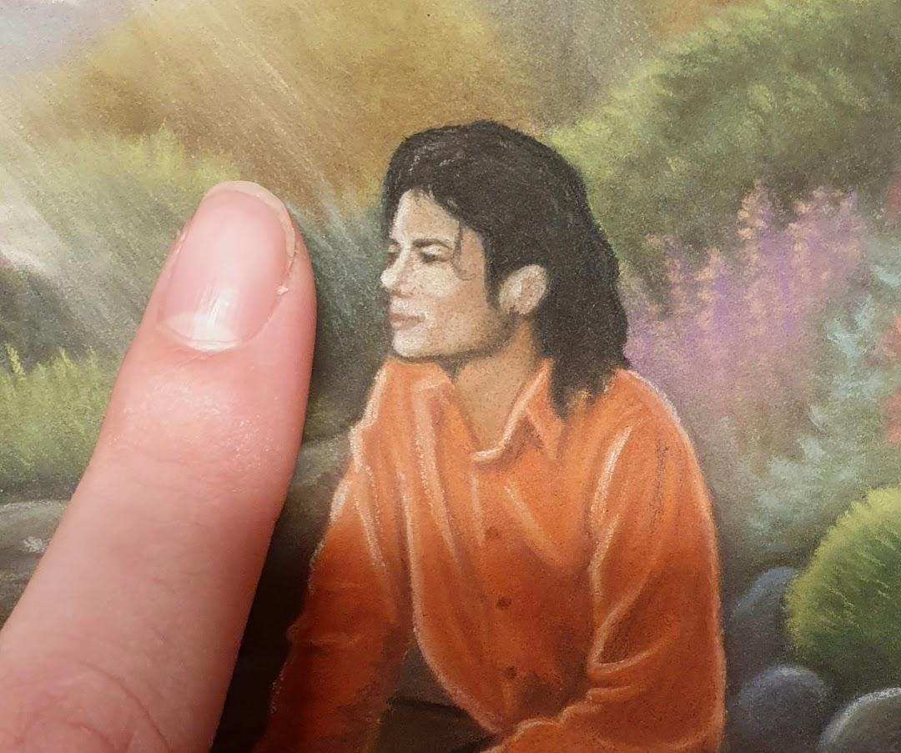
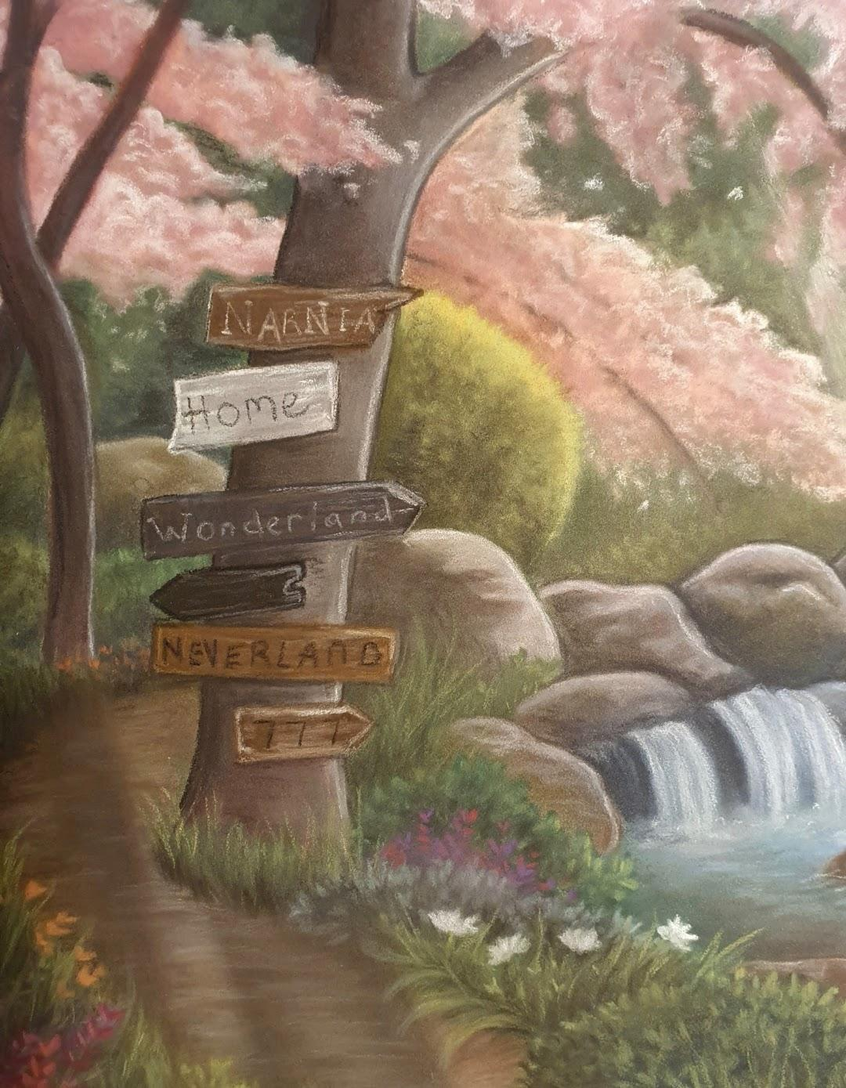
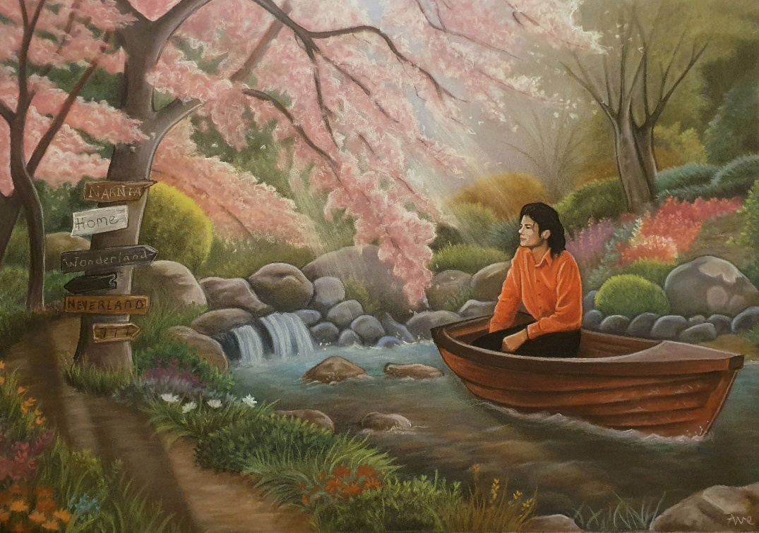
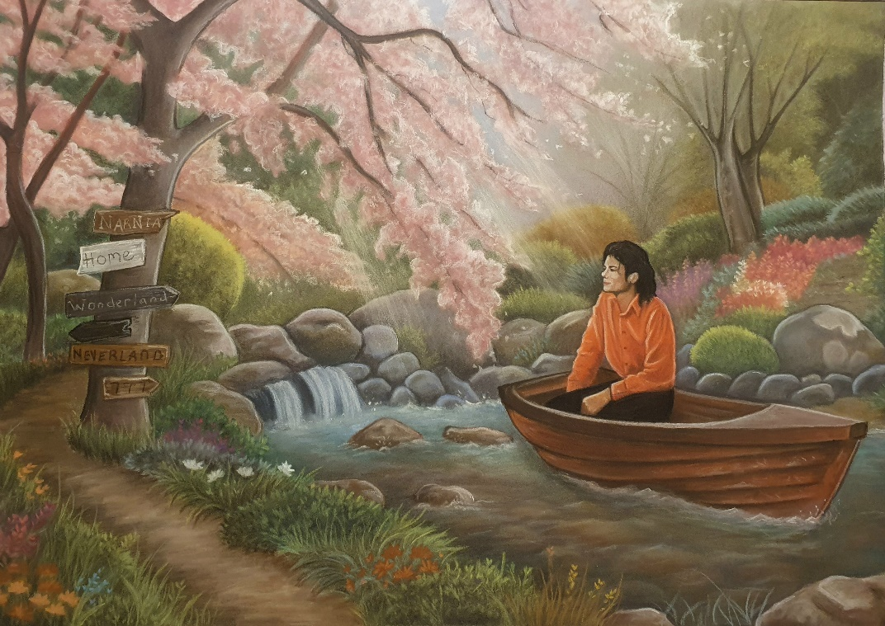
Finished artwork (larger image)
Before finishing the artwork, I decided it needed more depth. To create this I added sunrays peeking through the foliage of the cherry blossoms (see image lower left).

From there I decided it needed shadows. Using the direction of the sunrays, I was able to figure out the angle of the shadows in regards to where the sun hitting (see image lower right). I believe this greatly enhanced my artwork.
Artwork without the shadows of the trees and boat
Finished artwork

