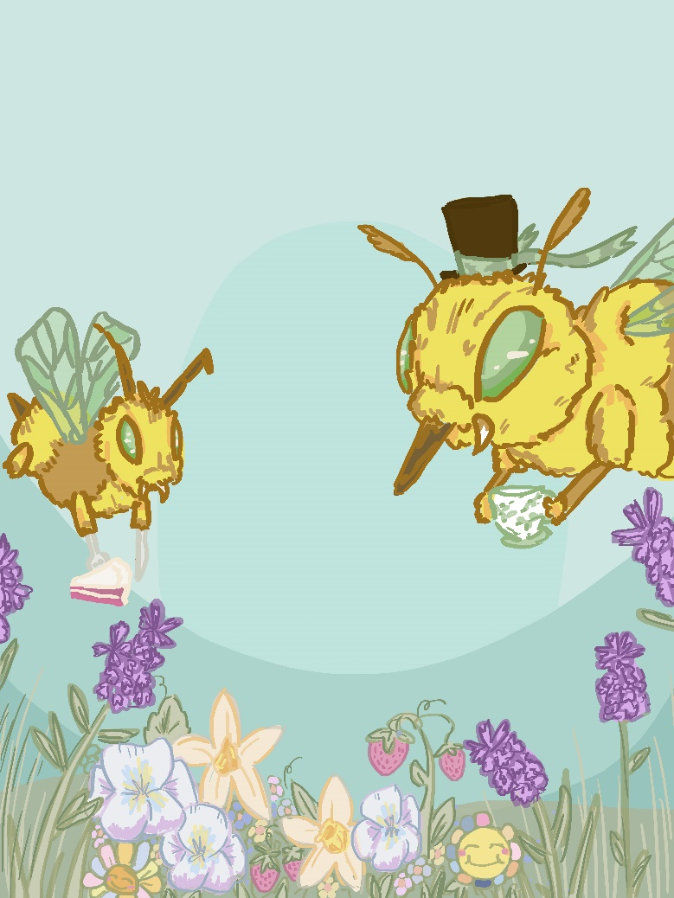
Tea for Bees

My digital artwork “Tea for Bees” portrays two abnormally large bees featuring silly accessories, such as the top hat and cake. I formulated the concept behind this work as I was sat inside, quarantining due to a (non-covid) related sickness. As I was confined to drinking tea within my four walls of boredom, a juvenile curiosity led me to picture an other-worldly more westernised “bee civilization”; One which might be found in a children’s picture book. As such, I mirrored the style and colour palette to suit. Bright although muted tones were incorporated to add to a more whimsical feel, combined with the scale of the bees rendering the flowers disproportionate.
I loosely stylised the anatomy of the bees after the Australian Teddy Bear Bee, to align more authentically with Australia’s own nature. Staring out from my window, I took further inspiration from the flowers I observed in neighbour’s yards, such as: daffodils, pansies and lavender. I have attempted to utilise a crowded composition as well as the juxtaposition of insects holding ‘man-made’ objects to enhance conceptual ideas of childhood imagination and youthful bliss.

