Representations of Women: The Action Hero

Rear Window (1954), Charlie’s Angels (2000), and Captain Marvel (2019) exemplify how the heroine archetype mirrors the progression of female empowerment in both society and Hollywood. Comparing these texts shows the female character’s journey – from an attractive sidepiece playing a secondary role, such as in Rear Window, to Captain Marvel, a strong, independent lead.

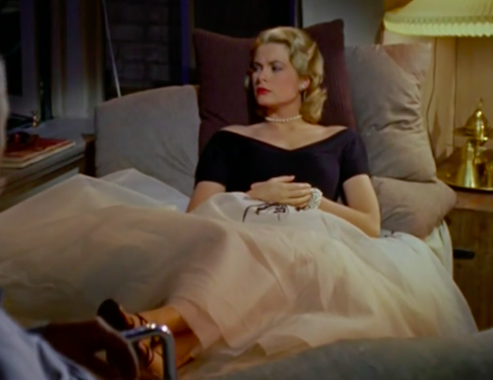
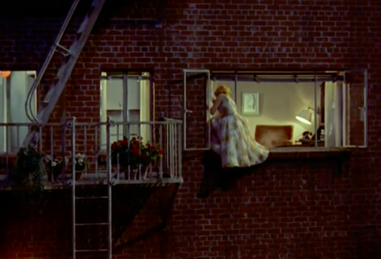
“American society in the 1950s was geared toward the family. Marriage and children were part of the national agenda.” (Mrs. America: Women's Roles in the 1950s, n.d.). Lisa demonstrates the trend for women to be the “happy homemaker” yet shows a minor moment of heroism (PBS, n.d.). She accepts this happy homemaker behaviour by following the latest fashion trends, wanting to please her boyfriend (Jeffries) and initiating constant discussion with Jeffries regarding their relationship and future. During WWII, women had the opportunity to work and gain freedom. However, in the 1950s, they were restricted to household duties. Very rarely were they allowed to undertake ‘masculine’ activities. “Despite her polished exterior, however, Lisa proves herself to be much more rebellious and bold than … previously imagined.” (Rear Window Character List, n.d.). Although advised not to, she climbs into an apartment to investigate, thus getting involved with the danger of the mystery. Despite this act of heroism, her character always focuses on her appearance and the male lead. Hitchcock upheld the typical female role as she looks glamourous, and with the exception of her one act of heroism, depends on Jeffries’ support and praise. Through this behaviour, Lisa’s character adhered to the expectations for women in the 1950’s – household carer and lover.

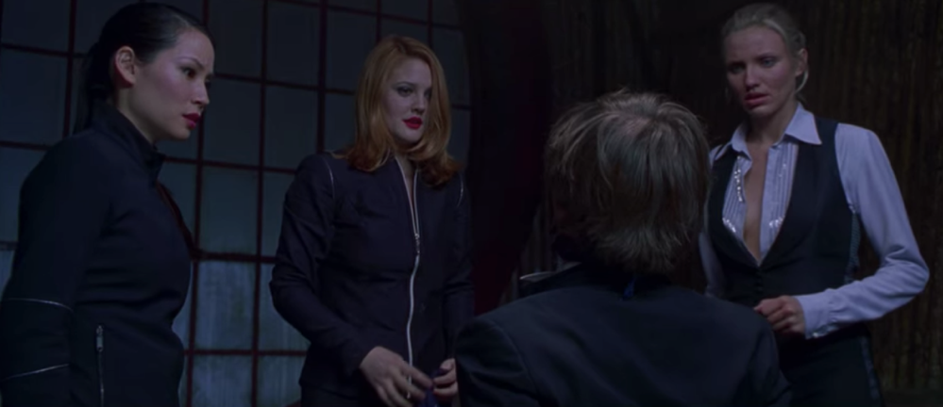
In the 2000’s feminism was growing from the introduction of girl power in 1990. McG’s 2000 film Charlie’s Angels used this movement to empower women, whilst exemplifying their feminine side through costumes, poses and concerns. In this film, the heroine archetype was focused on empowering women through their sexuality. Charlie’s Angels was an inspiration to many girls on “how to be really cool and independent and strong while holding on to [their] femininity and still having boys find [them] attractive. The film encourages the audience to accept the social idea of what a desirable feminist looks like.” (von Berg, 2017). Although women thought they were empowered when wearing revealing clothes, it was primarily dictated by the male gaze. While many women thought they were living in a world of equality, the reality was a hypersexualised environment dominated by the male perspective and their desires.

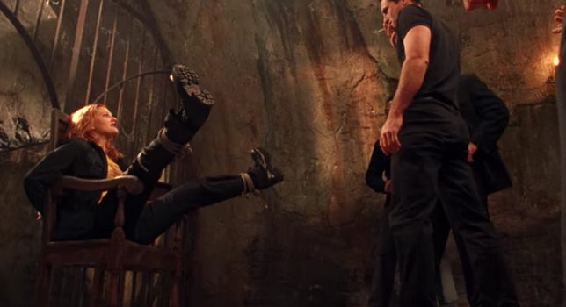
However, unlike Lisa in Rear Window, the characters in Charlie’s Angels are entirely self-sufficient and fight every battle. Their outfits are more practical than Lisa’s overflowing dress in Rear Window, however they are far from protective. This supposed progression is false however, as the entirety of the film is scattered with skimpy clothes, sexual innuendo and a determination to be loved. Looking at the film now, “Charlie’s Angels … fused girl power with sex appeal” in order for their power to be accepted by society (Dockterman, n.d.). Charlie’s Angels demonstrates the heroines progression from the usual role of assistant/sidekick to lead role which was accepted because the costuming, makeup, desire to be in a relationship and willingness to take orders from an unknown man supports the idea that women still obey and live by men’s rules. As such, Charlies Angels is a disillusion of female empowerment.

In 2019, movies such as Captain Marvel and Star Wars: The Force Awakens exhibit how the heroine archetype has been fully developed. The characters engage in the action without relying on their sexuality to get what they want with very few moments of ‘damsel in distress’. Anna Boden and Ryan Fleck took the opportunity in their 2019 film, Captain Marvel, to challenge the stereotypical sexualised and housebound woman, by creating a character who does not depend on a man. The 21st century’s social ideas of a feminist are displayed in this film – an unstoppable woman who depends on herself and occasionally her best friend (notably a woman). Furthermore, Captain Marvel’s armour is actually protective and non-revealing. The suit colours of blue, red, and gold are stereotypically male favoured, once again breaking tradition by wearing them as a heroine, with no men on her team. She does not need to dress in skimpy clothing to be powerful! Her strength and perseverance demonstrates how “she was a badass before she got her powers” (Itzkodd, 2019). In 2019, women were standing up for themselves, demanding equality and demonstrating their capabilities. In Captain Marvel, these values were portrayed through the strong female heroine who completes the mission and destroys the protagonists without relying heavily on men. Her actions and success reflects the contemporary view that women can undertake the same roles as men and don’t need to flaunt their femininity to be victorious. In this movie, the heroines progression is clear – no longer do they depend on men, such as in Rear Window, nor do they depend on their sexuality to succeed, such as in Charlie’s Angels. Instead, they overcome problems with their own strength while wearing appropriately protective clothes.

Through this close analysis of Rear Window, Charlie’s Angels and Captain Marvel, the exemplification of how the heroine archetype mirrors the progression of female empowerment in both society and Hollywood becomes clear. The characters in these texts are an indication of how women have been portrayed – a woman who depends on a man for all but a few scenes, to three crime fighting females who have been created by a man who “never got any girls growing up” (Spencer, 2019) and now a strong, independent woman who does not have to use her sexuality to be successful.

BIBLIOGRAPHY:
Beach, J 2018, Women's Rights in the 1950s, viewed 8 September 2021, <https://classroom.synonym.com/womens-rights-in-the-1950s-12082873.html>

Dockterman, E n.d., ‘The Evolution of the Female Action Hero’, Time Magazine, viewed 18 September 2021, <https://time.com/female-action-heroes/>

Itzkoff, D 2019, ‘Can ‘Captain Marvel’ Fix Marvel’s Woman Problem?’, The New York Times, 28 February, viewed 14 September 2021, <https://www.nytimes.com/2019/02/28/movies/captain-marvel.html>

Keith, M 2012, Rear Window and Post-War Gender Dynamics, The Ohio State University, viewed 12 September 2021, <https://lima.osu.edu/current-students/the-learning-center/the-writing-center/ohio-state-writing-awards/rear-window-and-post-war-gender-dynamics.html>

PBS n.d., Mrs. America: Women's Roles in the 1950s, viewed 13 September 2021, <https://www.pbs.org/wgbh/americanexperience/features/pill-mrs-america-womens-roles-1950s/>

Rear Window Character List n.d., Grade Saver, viewed 18 September 2021, <https://www.gradesaver.com/rear-window/study-guide/character-list>

Ryan, F 2018, ‘From Blair’s babes to TV ladettes, the 2000s was the emperor’s new clothes era of feminism’, The Guardian, 31 January, viewed 7 September 2021, <https://www.theguardian.com/lifeandstyle/2018/jan/31/2000s-frances-ryan-illusion-equality-achieved-ladette>

Spencer, A 2019, ‘Https://www.vanityfair.com/hollywood/2019/11/the-complicated-legacy-of-the-2000-charlies-angels’, Vanity Fair, 13 November, viewed 12 September 2021, <https://www.vanityfair.com/hollywood/2019/11/the-complicated-legacy-of-the-2000-charlies-angels>

von Berg, M 2017, Charlie’s Angels: Feminism or Fauxism?, Girls Empowerment Network, viewed 19 September 2021, <https://www.girlsempowermentnetwork.org/blog/charlies-angels-feminism-or-fauxism>

TEXTS USED:
Captain Marvel 2019, DVD, Walt Disney Studios Motion Pictures, Directed by Anna Boden and Ryan Fleck

Charlie's Angels 2000, DVD, Sony Pictures Entertainment Motion Picture Group, Directed by McG

Rear Window 1954, DVD, Paramount Pictures Studios, Directed by Alfred Hitchcock

