Miss Fisher’s Murder Mysteries: Research Presentation
Please be aware that this oral mentions abortion.

“We have a quaint custom here: the woman with the gun asks the questions.” Miss Fisher’s Murder Mysteries, both a novel and TV series, explored the expectations placed on women in the 1920s and through the character of Miss Fisher, challenged these. Kerry Greenwood’s novels and the subsequent TV show, follows and subverts the two famous crime fiction sub-genres of the 1920’s, cosy school, and hardboiled. With the use of witty dialogue, and film techniques such as mis-en-scene, costuming and camera angles, Miss Fisher’s Murder Mysteries reflects the concerns of the time about women’s roles in society, while staying loyal to the expectations of crime fiction.

Miss Fisher’s Murder Mysteries has over 20 novels and many TV episodes that are based on the books. I will primarily be drawing evidence and examples from the pilot episode, Cocaine Blues.

The first Miss Fisher book was published in 1989, titled Cocaine Blues. The 1970’s and 80’s saw the start of a progression towards a more equal society between men and women. In 1975, when the Australian born author Kerry Greenwood was 21, it was announced that “the period from 1976-1985 will be the United Nations Decade for Women” (‘Milestones for Australian women since 1975’, 2015). This helped to empower women and meant they had other options than being a housewife. The decade also saw many female political figures emerge for the first time in Australia’s history. These changes may have inspired Greenwood to create a character that rejects the labels society puts on her. As a result she chose to weave these modern views into the common concerns of the 1920’s.

“The 1920’s was a decade defined by change.” (Royal Australian Historical Society, 2021). This change was bittersweet as it progressed society but was also a time of mourning from the Great War and the Spanish Flu pandemic. Due to the deaths of many young men, some women ‘missed out’ on the social expectations – getting married and raising children. Thus, women like Miss Fisher, embraced these opportunities and were pioneers in a world where they were “unhampered by a reliance on men” (Miss Fisher’s Murder Mysteries teacher notes, 2011).

Also associated with the 1920s was the emergence of the Jazz age. It brought about changes related to women’s freedom, technology, the new suburban Australian dream, arts, and culture. In Miss Fisher’s Murder Mysteries, these changes are dominant, reinforcing the historical accuracy of the text. The first episode is set in 1928, “a pivotal time for the emancipation of women.” (Miss Fisher's Murder Mysteries concept document, 2011). Miss Fisher’s character contributes positively to this ongoing change and “variously alters the views of those in her social milieu” through her attitudes, clothing, and actions (Miss Fisher's Murder Mysteries concept document, 2011).

Critics believe that the TV series, while glamourous and exciting, is also “secretly informative about the oppression and suppression of women” in both the 1920s and the modern age (Marcus, 2015). The “episodes have touched on everything from women getting clandestine abortions to unsafe labour practices in a factory staffed by female employees.” (Marcus, 2015). Other critics noted the importance of raising historical women’s issues in modern society: “Period shows are a brilliant way to introduce feminism to TV, because they are set during eras that we consider far more backwards on gender equality issues, so bringing those issues up in the narrative feels more natural and palatable and non-political” (Marcus, 2015). These two comments reveal the strong feminist subtext contained in the series.

Miss Fisher’s Murder Mysteries combines the style of 1920s cosy school and hardboiled. Although Greenwood wrote her books in the late 1980s, she utilises the cosy school tropes and the hard-boiled detective fiction that were very popular in the 1920s. By combining these two highly contrasting styles, Greenwood could subvert expectations while also following the typical 1920’s style.

The cosy school style was introduced in the 1920’s as a way of escaping from the horrific experience of war and the hard reality of life. “Cozy mysteries are considered “gentle” books, with no graphic violence, profanity, or sex.” (Cozy Mystery, n.d.). The detective rarely has a well-paying job, but instead has connections with people who have these jobs, allowing her to call upon them for favours. In the first episode and book, most of these tropes are subverted, allowing Miss Fisher to be introduced as an independent and self-assured figure.

All the episodes are propelled with a strong undercurrent of violence, sex and danger which contributes to the needs from the 21st century audience. Miss Fisher consistently inserts herself into dangerous situations, in attempts to diminish harm to other people. She uses her feminine charm to distract and convince the antagonists that she’s nothing more than an available woman.
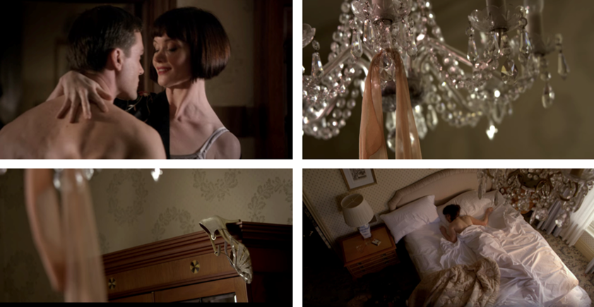
When not solving mysteries, Miss Fisher has a very active social life which often leads to her sleeping around. This is a huge subversion of the cosy school detective style and instead conforms more to the hardboiled style of including “graphic sex” (Encyclopaedia Britannica, n.d). Although the sex isn’t seen, it is strongly implied based on the after scenes which depict her lying in bed with clothes thrown around the room. Her sleeping around received some backlash from conservative American viewers. “I just wish that Miss Fisher wasn’t such a tramp, … It is hard to respect some one with such little morality.” (Morris, 2013). In response, Greenwood brought up James Bond and The Saint: “No one thinks their multiple lovers are indications of slutishness.” (Morris, 2013). Miss Fisher’s sexual freedom with men is symbolic of her social freedom as she abandons the expectations of the time.

Despite subverting many tropes from the cosy school style, Miss Fisher does conform to some, such as having friends with useful skills. To solve crimes, she relies on her doctor friend and two policemen, allowing her to participate and assist in police investigations. This arrangement of friends conforms to the cosy school trope of the detective needing her friends to help her solve the crime.

Hard-boiled crime fiction is “a tough, unsentimental style of American crime writing that brought a new tone of earthy realism or naturalism to the field of detective fiction.” (Encyclopaedia Britannica, n.d.). The murders in the show often intertwine with social issues of the 1920’s such as gambling, communism, etc. These topics fit the hard-boiled style as they are realistic, instead of the cosy school topics which are intertwined with love, money, or desire.

Violence and slang-based dialogue, elements of hardboiled, also feature in the show. Violence builds tension, while also making it more realistic. Miss Fisher’s speaking style is more composed rather than slangy, however she does have witty one-liners such as “I’m concealing a lot of things. That’s what a lady does” which contribute to her persona of being confident and clever. This is one example of her many witty lines that contribute to her character as well as showing how she conforms to the expectations of hardboiled detective fiction. I believe that Greenwood wanted to use these two styles as they contrast greatly but are very common for the 1920’s. A mixture of the two was very rare and so it modernises her work for the 20th century and onwards.

Miss Fisher is “the embodiment of the Jazz Age liberate female” as shown through her choice in clothing, her drinking and smoking (Frank and Johnson-Woods, 2015). The inclusion of such an expressive character subverts the expectations of the 1920’s cosy school detectives – quiet, unassuming, and often a spinster, such as Miss Marples or the gentle and retired Mr Poirot. In hardboiled crime fiction, the detective is often “a tough, cynical guy with a gun” (Hardboiled detective, n.d.). Miss Fisher is tough and occasionally has a cynical outlook on life but prefers to try and stay positive. Like the hardboiled detectives, Miss Fisher carries a gun with her.

Fiona Eagger and Debra Cox, the producers of Miss Fisher’s Murder Mysteries, employed costume, lighting, carefully constructed mis-en-scene, and witty dialogue among other techniques, to explore the expectations on women in the 1920s and conversely, how the character of Miss Fisher is a distinct individual of the time.

According to academic sources, costuming has two important parts in a TV show: “the first is to support the narrative by creating authentic characters (people); and the second is composition, to provide balance within the frame by using colour, texture and silhouette.” (Green, n.d.). In Miss Fisher’s Murder Mysteries, Marion Boyce, costume designer, ensured the costumes were historically accurate to give the show credibility, while showing Miss Fisher’s personality through her clothing. Miss Fisher is “glamourous, physically daring and dismissive of social conventions”, thus allowing her wardrobe to be flamboyant, colourful, and varied (Green,n .d.). “Her costumes define not only her independence, but social status, … Phryne embraces and flaunts these freedoms and is the poster girl for this era.” (Gordon, 2017). In many of the episodes, Miss Fisher breaks tradition and wears pants for practical reasons and hence demonstrates her dismissiveness of social conventions.

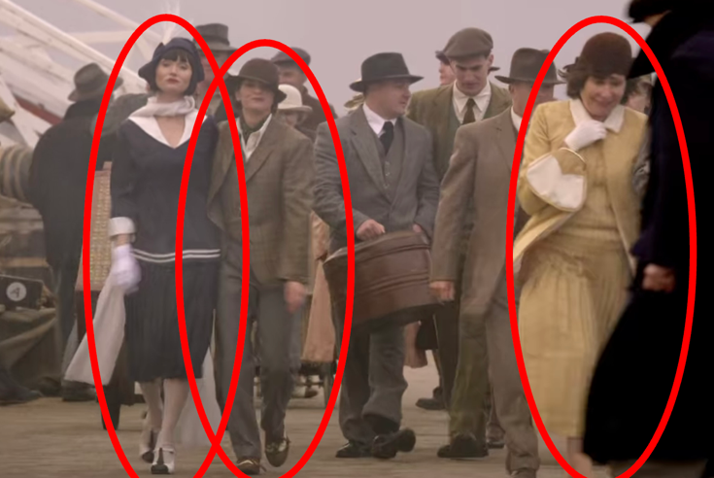
As seen in these examples, Miss Fisher’s outfit highlights her against the drab colours of the population, drawing the attention to her lack of conformity with society’s expectations. Furthermore, this shot reveals three very different ways of dressing. The woman in yellow – dressed conservatively in a common style for middle-class women, Miss Fisher’s friend dressed in a suit which would have been very rare and finally Miss Fisher, dressed in a blue ensemble with a lowcut neckline. Boyce uses these three varied outfits to establish the character’s personality.

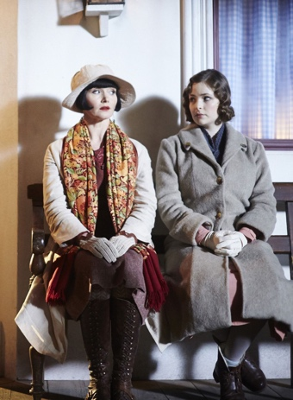
Another contrast is Miss Fisher’s assistant and friend Dot. She “is clearly subdued, sensible, and down to earth.” (Gordon, 2017), preferring to wear the more traditional and simple styles that are practical and cheap. Miss Fisher’s style contrasts with the others, thus providing another insight into her character which showed that she wasn’t going to conform to the constraints of the 1920s society.

“The variance of camera angles in filmmaking are used to help enhance the narrative, the theme, and the overall mood of the film.” (Filming 101: types of camera shots and angles, 2019). In Cocaine Blues a variety of camera angles are employed to add depth to the production.

Although a very commonly used angle, the closeup is powerful. It provides the audience with an intimate look at the character’s face, and the emotions they are experiencing. This shot is taken from a scene where Miss Fisher is at a jail, talking to her sister’s murderer. The closeup reveals Miss Fisher’s seriousness, reflecting pain and anger towards the character she’s talking to.

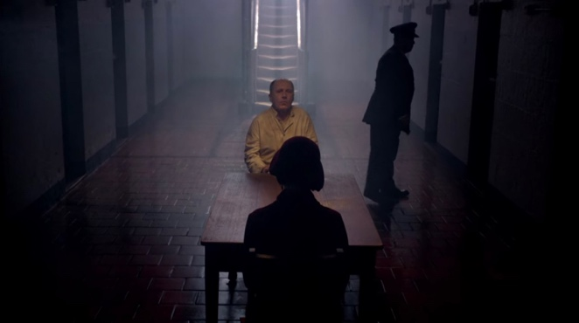
Lighting is another aspect that adds to the narrative, theme, and mood. Here, the hanging lights in the background are the only visible light source. Her face is shadowed, symbolising how her visit isn’t a positive one.

Miss Fisher’s Murder Mysteries explored the expectations placed on women in the 1920’s and through the character of Miss Fisher, challenged these. The series draws inspiration from the contrasting styles of the 1920s murder mystery: cosy school and hardboiled. This contrast allows the creators to conform and subvert expectations as they wished. The use of witty dialogue, mis-en-scene, costuming, lighting, and camera angles, assists the author and producers in reflecting the concerns of the time about women’s roles in society while producing an engaging and exciting show. Thank you.

Bibliography:
Camera movements: everything you need to know n.d., Nashville Film Institute, viewed 22 March 2022, <https://www.nfi.edu/camera-movements/#:~:text=Panning%20can%20help%20you%20establish,that%20were%20previously%20off%2Dscreen.>

‘Cocaine Blues’ 2012, television program, ABC, 24 February

Constable Hugh Collins n.d., ABC, viewed 21 March 2022, <https://www.abc.net.au/tv/phrynefisher/characters/hugh_collins.htm>

Cozy mystery n.d., TV Tropes, viewed 25 March 2022, <https://tvtropes.org/pmwiki/pmwiki.php/Main/CozyMystery>

Dr Mac n.d., ABC, viewed 21 March 2022, <https://www.abc.net.au/tv/phrynefisher/characters/dr_mac.htm>

Encyclopaedia Britannica n.d., Hard-boiled fiction, viewed 25 March 2022, <https://www.britannica.com/art/hard-boiled-fiction>

Filming 101: types of camera shots and angles 2019, Polarpro, viewed 22 March 2022, <https://www.polarprofilters.com/blogs/polarpro/filmmaking-101-types-of-camera-shots-and-angles>

Franks, R & Johnson-Woods, T, 2015, ‘Phryne Fisher: Feminism and Modernism in Historical Crime Fiction’, The Australian Journal of Crime Fiction, viewed 20 March 2022, <http://www.australiancrimefiction.com/phyrne-fisher>

Gordon, T 2017, How 'Miss Fisher's Murder Mysteries' captures the roaring fashion of the 1920s, KCET, viewed 19 March 2022, <https://www.kcet.org/shows/miss-fishers-murder-mysteries/how-miss-fishers-murder-mysteries-captures-the-roaring-fashion-of-the-1920s-photos>

Green, T n.d., Deep dive: Marion Boyce, National Film and Sound Archive, viewed 19 March 2022, <https://www.nfsa.gov.au/latest/deep-dive-marion-boyce-costume-designer>

Hardboiled Detective n.d., TV Tropes, viewed 25 March 2022, <https://tvtropes.org/pmwiki/pmwiki.php/Main/HardboiledDetective>

Marcus, L 2015, ‘How Miss Fisher’s Murder Mysteries conquered America’, The Guardian, 14 October, viewed 26 March 2022, <https://www.theguardian.com/tv-and-radio/2015/oct/13/how-miss-fishers-mysteries-conquered-america>

‘Milestones for Australian women since 1975’ 2015, ABC News, viewed 14 March 2022, <https://www.abc.net.au/news/2015-09-24/beijing+20:-milestones-for-australian-women-since-1975/6792126?nw=0&r=Gallery>

Miss Fisher's Murder Mysteries concept document 2011, ABC, pdf, viewed 18 March 2022, <https://www.abc.net.au/tv/phrynefisher/classroom/MissFisher_ConceptDocument.pdf>

Miss Fisher's Murder Mysteries teacher notes - English 2011, ABC, pdf, viewed 18 March 2022, <https://www.abc.net.au/tv/phrynefisher/classroom/MissFisher_English_TeacherNotes.pdf>

Miss Fisher's Murder Mysteries themes 2011, ABC, pdf, viewed 19 March 2022, <https://www.abc.net.au/tv/phrynefisher/classroom/MissFisher_English_Themes.pdf>

Morris, L 2013, ‘Miss Fisher's Murder Mysteries author dismisses 'tramp' criticisms’, Sydney Morning Herald, 18 November, viewed 21 March 2022, <https://www.smh.com.au/entertainment/books/miss-fishers-murder-mysteries-author-dismisses-tramp-criticisms-20131118-2xqep.html>

‘The National Times, September 5 – 11’ 1982, ABC News, 5 September, viewed 14 March 2022, <https://www.abc.net.au/news/2015-09-23/the-national-times2c-september-5---112c-1982/6798942?nw=0>

Royal Australian Historical Society 2021, Exciting New World: Australia in the 1920s, viewed 19 March 2022, <https://www.rahs.org.au/exciting-new-world-australia-in-the-1920s/?utm_source=rss&utm_medium=rss&utm_campaign=exciting-new-world-australia-in-the-1920s>

Schmidt, L 2008, ‘Profile: Kerry Greenwood’, Sydney Morning Herald, 25 June, viewed 14 March 2022, <https://www.smh.com.au/business/profile-kerry-greenwood-20080625-gdsj93.html>

Photo Bibliography:
‘Cocaine Blues’ 2012, television program, ABC, 24 February

Miss Fisher n.d., Photograph, Filmink, viewed 27 March 2022, <https://www.filmink.com.au/miss-fishers-murder-mysteries-movie-happening/>

Miss Fisher Murder Mysteries costume gallery n.d., Photograph, Pinterest, viewed 27 March 2022, <https://www.pinterest.com.au/pin/414753446906471183/>

Phryne & Dot n.d., Photograph, Fanpop, viewed 27 March 2022, <https://www.fanpop.com/clubs/miss-fishers-murder-mysteries/images/35224670/title/phryne-dot-photo>

