REFRACTION

This project was created solely to experiment with a new medium. This was made with Adobe Photoshop and Adobe Illustrator. It was the result of one of my first times using Illustrator. I was experimenting with the different tools within the program, such as the 3d function and all of the basic tools.

The first thing in order to achieve this look was creating the layout in Illustrator. I also used the 3d function in order to make the text in the centre.
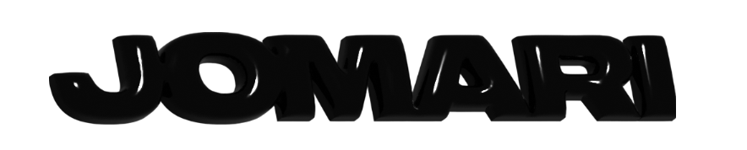
Above is what the 3d text looked like. After taking the assets from Illustrator into Photoshop, I utilised several techniques in order to get the final image. Gradient maps, displacement maps and different layer blending styles were all used in order to achieve the final look.

Attached below is the Photoshop project file.
https://www.dropbox.com/s/lzvkby4g7g62vfg/YT%20BANNER.psd?dl=0

