To the town
  - A short informative video about Bungendore.

Film Production

Identification of Need/Problem & Opportunity
The aim of this Design Project is to showcase the local community both creatively and informatively in the form of digital media/video. Through a device, the product can be clicked on and watched, and the viewer will gain an understanding of the local community or will watch it for entertainment. The aesthetics will be based on the local environment and showcase its colours. The budget will be $300 and will be completed by September 2021.

Problem & Opportunity
Businesses in small towns do not get the same opportunities to advertise in their local area and beyond. It is too expensive to advertise on television and other mediums that involve digital technology. This provides the opportunity to both promote the businesses and landscapes and create educational material as well. Both visitors and residents will be interested in this as they are unaware of the local appeal. By researching, interviewing and documenting, I believe there is an opportunity to create a video that showcases the Bungendore and the surrounding region.

Problem:
Small towns do not have access/funds for digital advertising, and visitors want information.
Opportunity:
A video that advertises the local environment and business.

From the constructed problem and opportunity, I was able to research statistics to find the need in the market. I used the statistics to justify my reasoning and make further decisions on the project. By using different perspectives, I was able to see that this need can be applied both in a niche market and globally, yet there is no competition in a small town, hence the decision to base it in a small town/rural area.

Personal |  | Time & Management |  | Skill
Drivers Licence  Budget | I am unable to drive myself to and from places yet.  I am not wealthy, and although I care deeply for this project, I am not willing to spend too much on this project. | Work  Other subjects  Family holidays/family time | Weekends (4 to 8-hour shifts)  Other subjects require assessments and homework to be completed.  My family regularly travels during the holidays. | Animation techniques and/or programs | I do not know how to animate in a video.
I will get my licence in the Christmas Holidays. I will limit myself to $300 for this project. |  | I will manage these constraints by using to-do lists and a calendar in my phone. I will ask to not go on extended holidays but will still enjoy some time with my family. |  | I will use my time wisely to learn these new skills in order to use them in my project. I will ask experts in the field.

Constraints

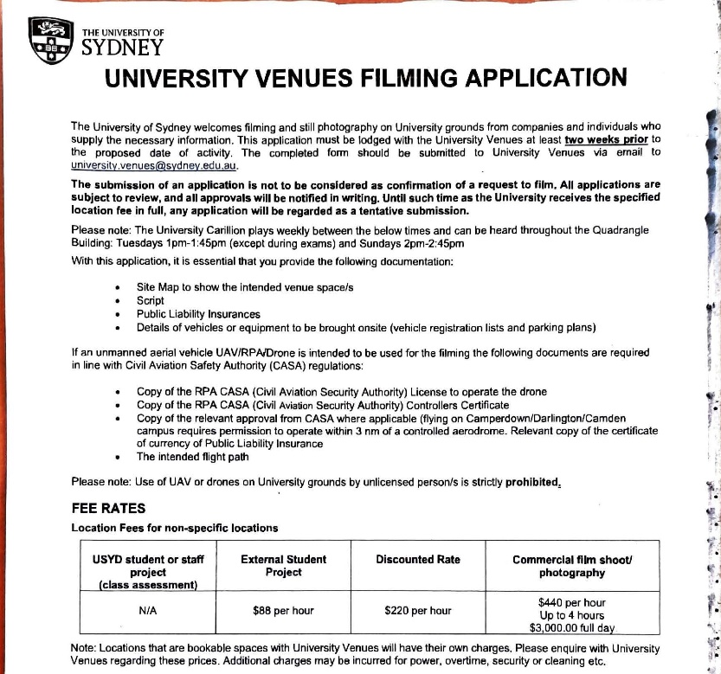

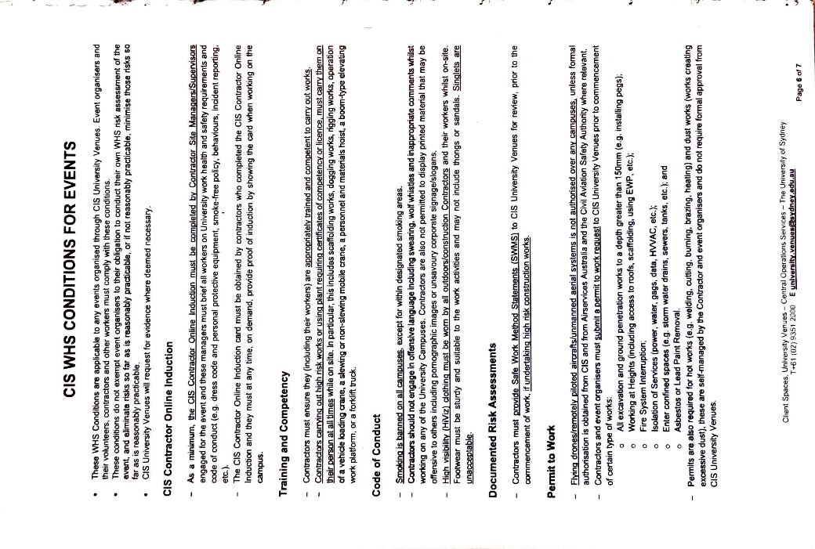
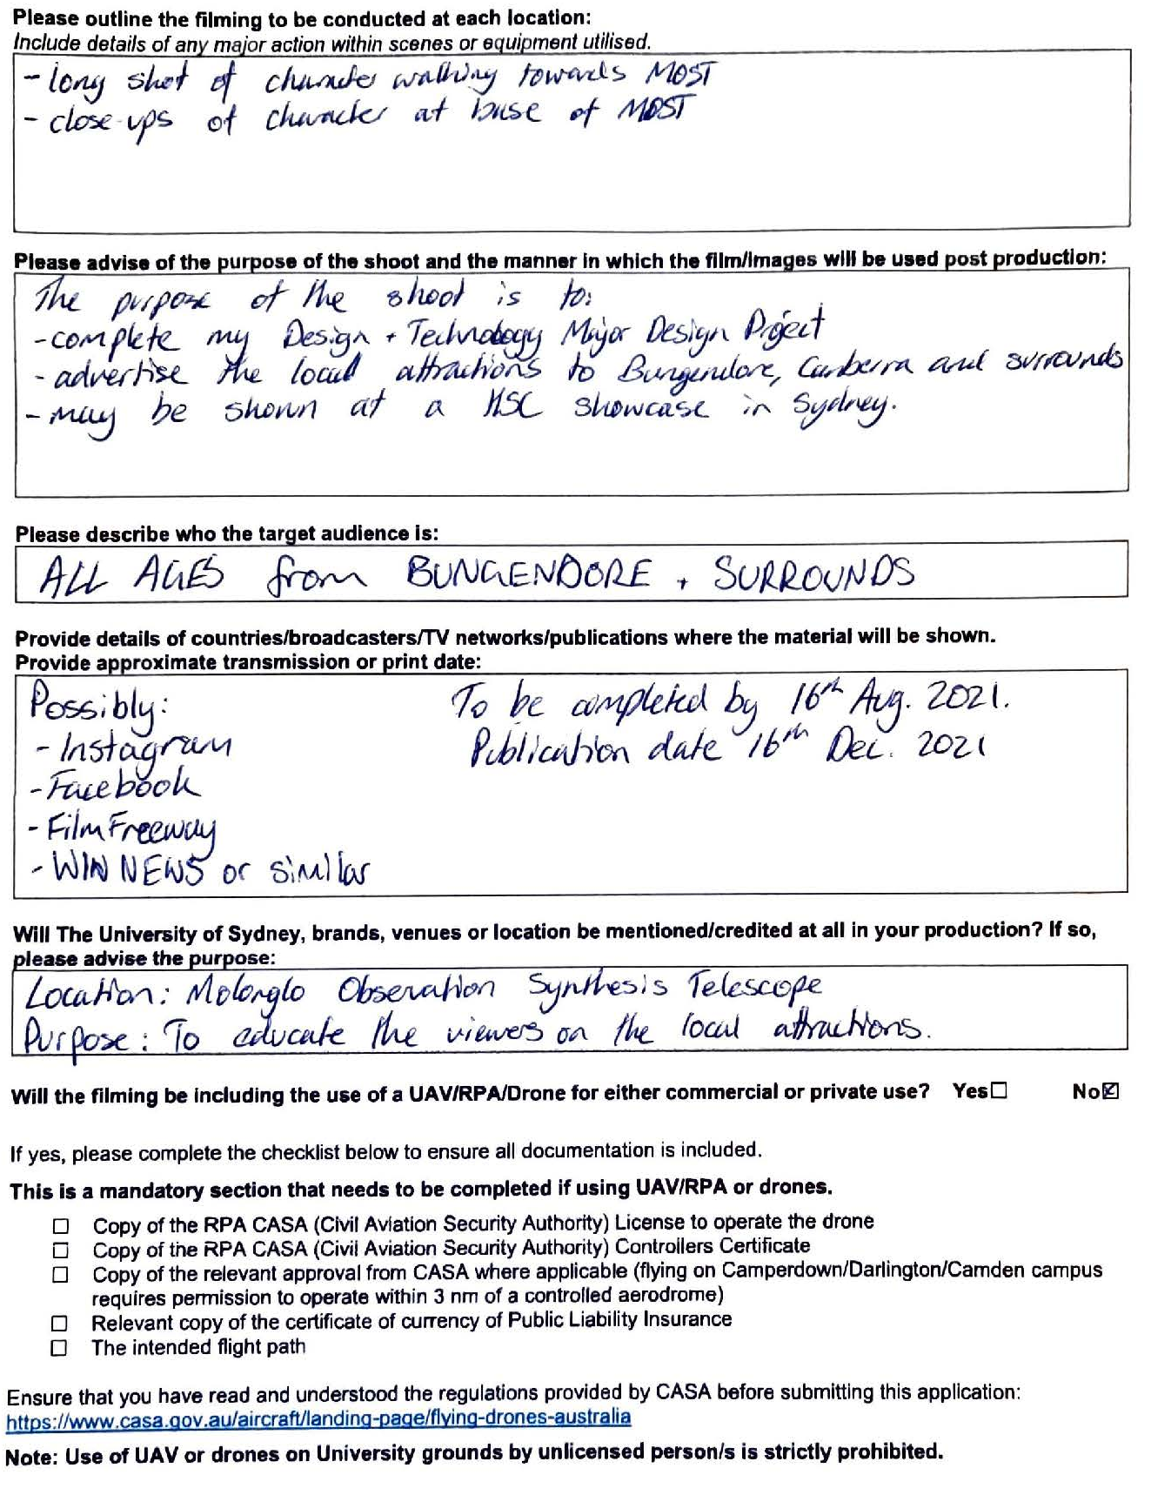

Action Plan
Areas of Investigation
Impact on the Individual, Society and the Environment
Research Target Market
Identification of need.

Experimentation
Organise Cast, Crew and Locations.
Final Design Drawings
Find Locations and Experimentation

Evaluation on Criteria for Success
Analysis of Factors
Edit
Film

Target Market Research

Selected Market
The selected market is the local community of Bungendore and the Surrounding Regions. Nearby, Canberra is becoming more interested in Bungendore. The Canberra market will be targeted in the consumerism side of the product: Bungendore’s community is the need and target market, and Canberra is just the target market. The businesses of Bungendore would like my product because it is an incredibly cheap advertising medium. After the drought, bushfires, and COVID-19, this small town needs to get back up on its feet. Bungendore residents and Canberrans would love this product because they are able to understand what is in and around Bungendore and are not left in the dark when they visit. By watching my videos, they are able to grasp the best features of this region.

The Key Factors
The key factors that define this market are the younger demographic, the lack digital media showcasing this region, the love for movies and the amount of people working in Bungendore. These are the driving features that make this market, over another, need my product. Having a younger demographic means there is more of an appeal for social media and television. Therefore, the product will be in this category (digital media). With 80% of the survey partakers being under 35, there is a large market in this region. This is the main reason I have chosen this market to base my product. My target market is based in the Bungendore region because there is a lack of digital media advertising. More than half of the population expressed that there wasn’t enough representation for themselves and their community. 83% of responders said they haven’t seen an increase in movies locally, providing a market for my product. Therefore, I have chosen this region because there isn’t any competition, and they wish there to be this option. In Bungendore and Canberra, there is a significant love for watching and creating movies. On the scale of 1-10 (with 10 being ‘I absolutely love movies’), 96% of people chose 7 or higher. This confirms my determination to make a movie/digital media in the region. Through the survey, it came to my attention that the majority of people in the region do not work in Bungendore. This is a huge opportunity, because I am able to base my target market on those who do not know about Bungendore and its businesses. Over 90% of people who completed the survey did not work in Bungendore. With this outstanding information, it confirms my justification of the target market being in both Bungendore and Canberra.

