UC Creative Competition 2021

Title: Yearning
Artist: Mahima Gilhotra
School: Radford College
Submission subcategory: Digital media
Year: 2021
Dimensions: Square thumbnail 1920x1920px Original 2048x2732px

‘Yearning’ is a digital illustration based on the idea of someone yearning for something they cannot have. To illustrate the individual’s desire withing the painting, I have used warm tones and strokes to convey the idea of blaze-like desire. To portray the idea that the figure cannot get what they desire and is stuck in their moment of yearning, I have used simplistic, framing features to hold the figure in place. This digital illustration was created on the platform, Procreate, on my iPad Pro.

Thumbnail
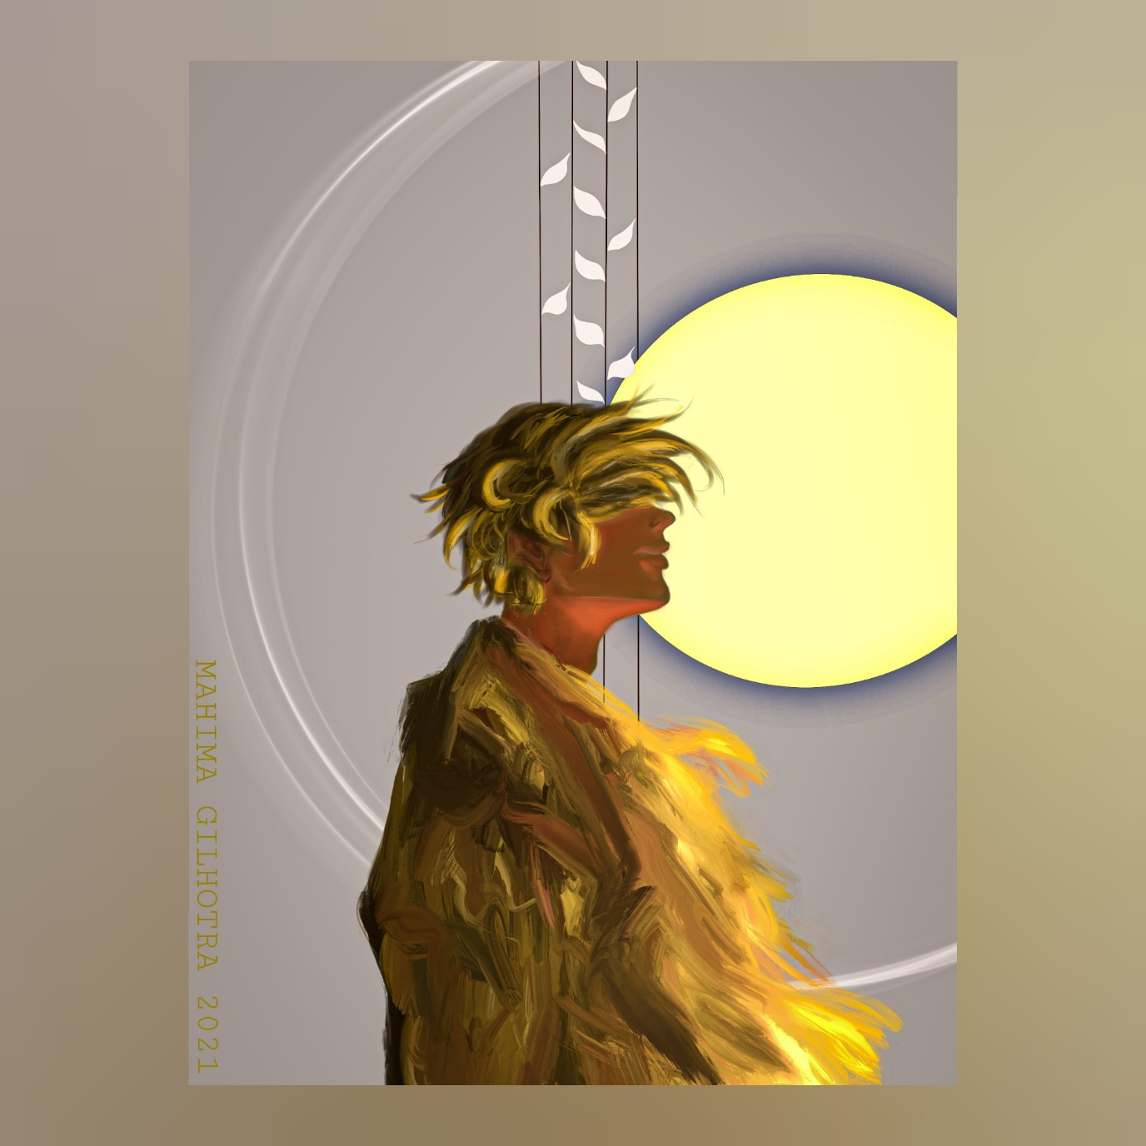

Original painting
