Design Brief
My design is a contemporary influenced floating home, that combines the beauty of its aquatic soundings with sleek, simplistic architecture. It utiliss reclaimed cost effective materials along with sustainable features, to suit the client's eco-conscious way of life.
The proposed dwelling will sit on a 6000mm (L) x 6000mm (W) floating concrete and Styrofoam platform making it relocatable by water. The curved circular structure will reach a height of 4200mm. Creating a house designed to be floating brings a client who seeks and enjoys being in and around a water environment. Living on water provides great opportunity for water sport recreation, for example fishing, surfing, snorkelling and water-skiing, as well as access to waterfront entertainment and hospitality, like water front restaurants and shops. In countries or areas where land property is limited, lakes, ocean bays, and rivers can also provide suitable cheap property. The concrete base will be able to withstand colder climates in which lakes may freeze over, making the house only relocatable in summer months or locations with warm climates.
This floating tiny house will consist of the following features:
- Queen size bed on loft above bathroom and kitchen area
- Recycled dark timber cladding on the exterior
- Reclaimed steel framing
- Large floor to celling windows
- Solar and wind energy generating system
- Dark sleek finishes
- Skylight above bed loft area
- Floating stairs to loft platform

Design athletics and materials
I aim to meet my client's eco-conscious lifestyle as well as design a contemporary home that appears high-end but is affordable. The design will incorporate modern elements and sleek dark finishes, long curves and large windows, along with intuitive features such as a loft bed and clever storage. I am inspired by black contemporary architecture. The simplistic clean finishes, bold dark colours and warm lighting will be the aesthetic of this floating tiny house. I wish to create a spiral shaped home with panoramic views over the ocean and rivers. Clean curves will mimic the flow of water. Using recycled timbers, plastics, steel and other similar materials will help my design to have minimal environmental impact and keep a low budget. (TPM Builders, 2019). The building's structural design and colour palette will inform the contemporary sleek style I am aiming for. Concrete and Styrofoam will be used in the floating platform. Dark wood and black steel will create the walls and roof of the house and timber or plastic wrapped timber will frame the windows. Tile may be used in the bathroom area of the tiny house or as a simple splash back in the kitchen, but the house will primarily consist of recycled and reclaimed wood, steel and plastic.

Concept sketches of floating platform
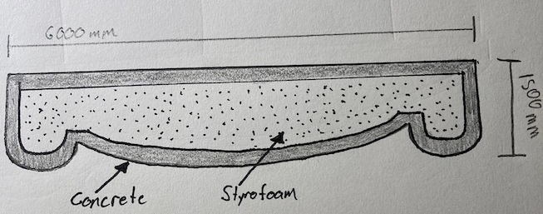
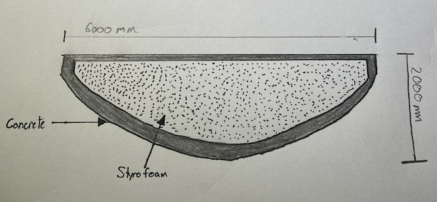

Sustainability
The brief asks to include one sustainable feature in the design. One issue of a floating house is an accessible and affordable constant supply of electricity. Creating energy through a portable generator does not match the client's eco-friendly style because over time it is not environmentally sustainable and can often be loud and interrupt the peace of aquatic surroundings. To solve this issue, solar panels will cover the roofing and any shade panels on the home, generating energy from the sun that will produce electricity for appliances, hot water and lighting.
The benefits of solar panels include:
- Environmentally friendly
- Cheap to run
- Cost effective over time
- Create independently run houses
- Source of clean renewable energy
- Low maintenance
- Come in any shape
The down-side to solar panelling is it becomes useless in overcast weather and in areas of the world where the nights become longer and the sun is not as reliable. My design will feature a solar storage battery that holds excess energy for less energy producing days as well as regulates the output of energy used by the home. (SolarQuotes,2021)
My design of this floating tiny house will also eventually have plans to incorporate more sustainable features such as self a composting toilet, and water purification system. These features along with the solar panels aim to create a self-sufficient home, reducing the need to travel to land.

Mood-Board of ideas and inspiration
