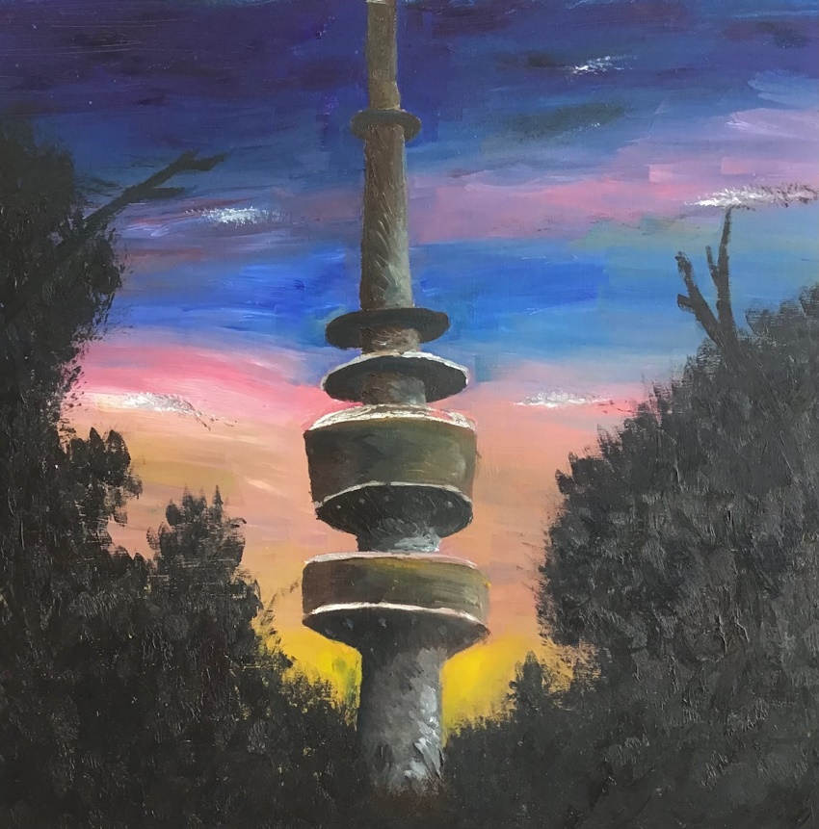  Visual Communication design | Telstra Tower Variant, 2021  Sophie Couldrick  Oil Paint on wooden board  Dimensions: 30.5cm x 30.5cm  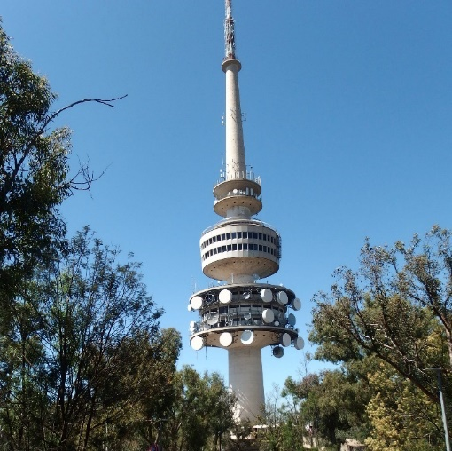  Sophie Couldrick

Telstra Tower Variant is a landscape painting, informed by the principles of impressionism, with the strong emphasis of light and colour, and the use of short, thick strokes of paint to capture the essence of the object rather than the subject's details.
My work, Telstra Tower Variant was based on and influenced by a personal photo. The photograph is of the well-known icon, Telstra Tower, located at the top of Black Mountain, Canberra.
I intended to capture the essence of the landscape through the emphasis of light and colour. To refrain the detail of the painting and the excessively ornate Telstra Tower, I strategically removed all the chaotic extras typically seen on the tower. After multiple variational experiments of colour (ranging from green to blue and even orange), I went with a purple sky. I wanted more vibrant colours that stood out against the silhouette of the trees, against the sky, compared to a dull musty purple, which resulted in the final sky consisting of yellows, pinks and blues.

