Visual Communication Design
Oneli Adikari Year 11 Daramalan College 2021

Daramalan College Student Website (Daranet) Icon Design

At Daramalan College a design icon competition was held to gain an icon for the school’s student website, ‘Daranet’ where currently the icon is the school logo. My design for the icon was greatly inspired by the original Daramalan College eagle (seen in figure 1). The eagle is a necessary addition to the icon because it’s one thing that represents Daramalan College since “Strong in Faith” or “Fortes in Fide”, the latin phrase, is our motto and strength and faith is represented by the wedge-tailed eagle. My design doesn’t look the same as the original eagle that’s seen in figure 1 but I wanted to create somewhat of a similarity.
I aimed for a minimalistic look because it seems to be taking over a lot of logos and icons in the present day and I think I achieved that goal because there aren’t any fine details. From the original Daramalan College eagle I included a close representation to the head of the eagle, along with the wing design. It does look a bit more compressed since the original eagle is quite long. Red and Black, along with white, had to be used because they are the school colours and without it, it wouldn’t be a ‘Daranet’ icon. The triangle that’s seen at the rear end of the body of the eagle is the representation to the wedge-tail of a wedge-tailed eagle. Finally, the “D” inside of the wing represents the “D” in Daranet, so it creates a connection to the websites name.

Figure 1: Original Daramalan School eagle

The Icon
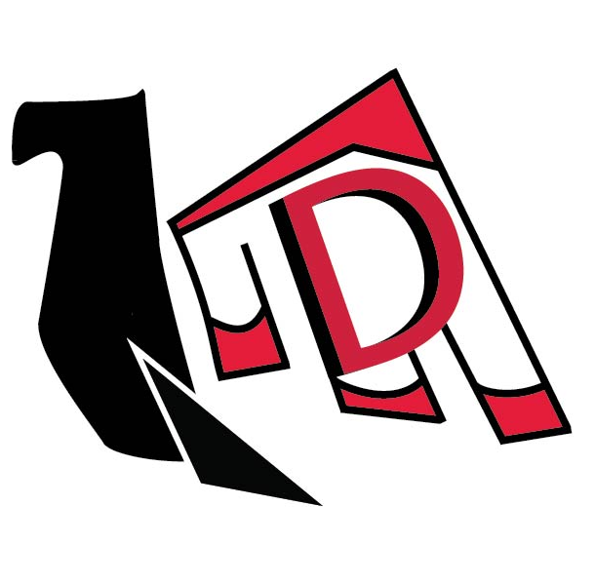
Figure 2: Oneli Adikari Daranet icon design, colour with no name.

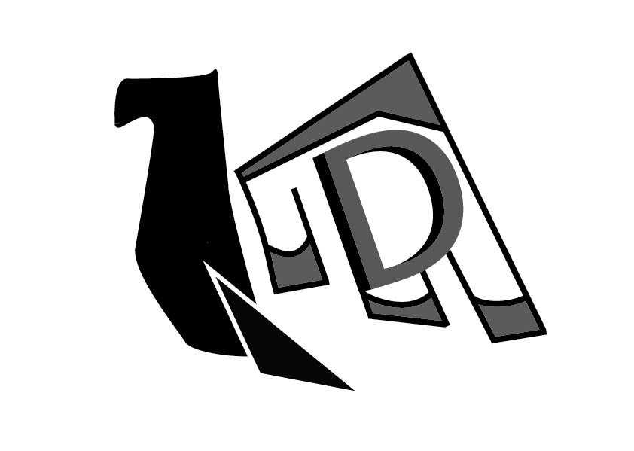
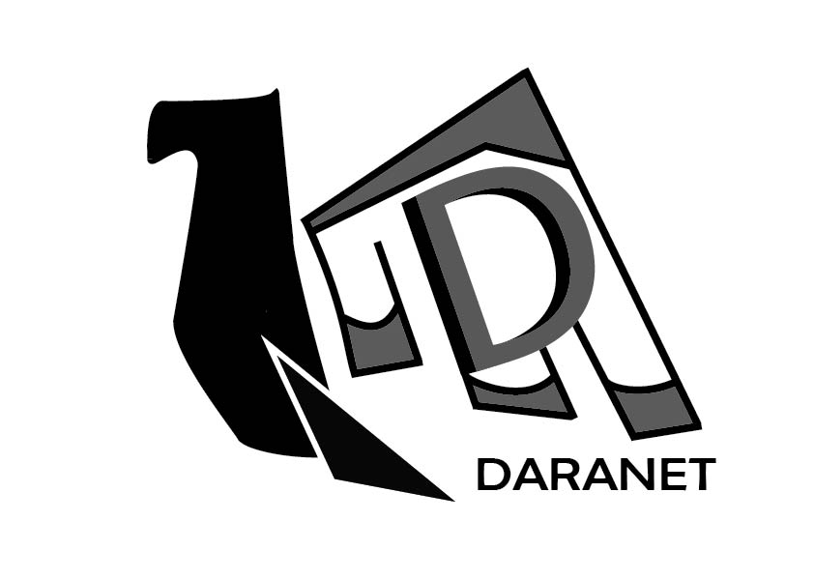
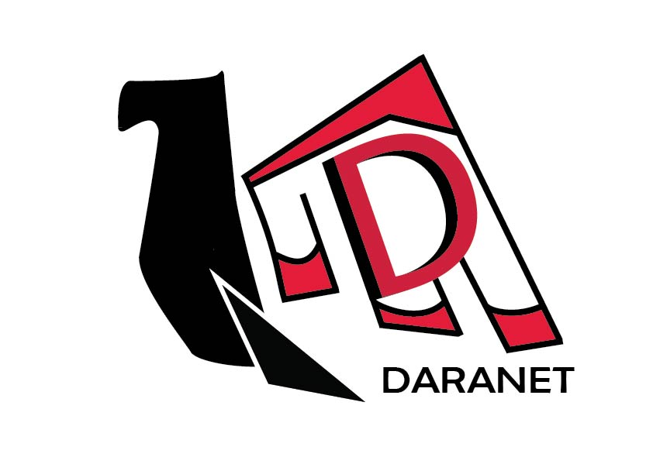
Additional images
Figure 5: Oneli Adikari Daranet icon design, greyscale with no name.
Figure 4: Oneli Adikari Daranet icon design, greyscale with name.
Figure 3: Oneli Adikari Daranet icon design, colour with name.

