Investigate
Identify problem
My track record of looking after plants is not fantastic and I would like to change that. I love indoor plants especially ones that you can use for cooking as grocery store ones tend to be less fresh. I would also like to grow all year round plants which do not suit the Canberra climate.
Propose a solution
The solution I have devised is a gardening system which helps to keep indoor plants alive and healthy as well as widen the range of plants which are usually unable to grow in Canberra. This project will be an indoor gardening tool allowing most plants to be grown all year round.
Timeline

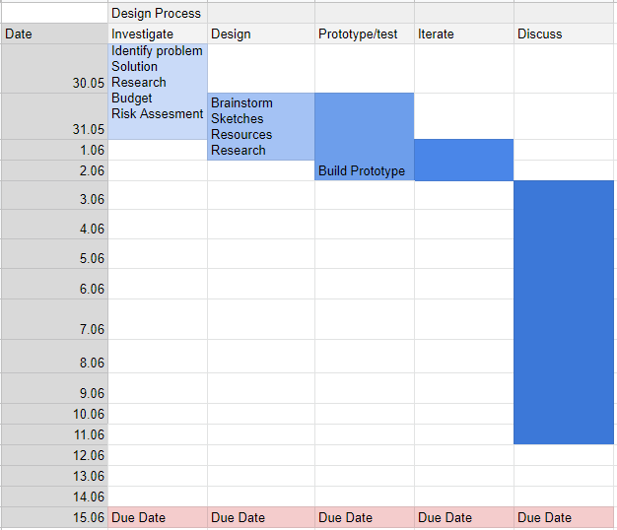
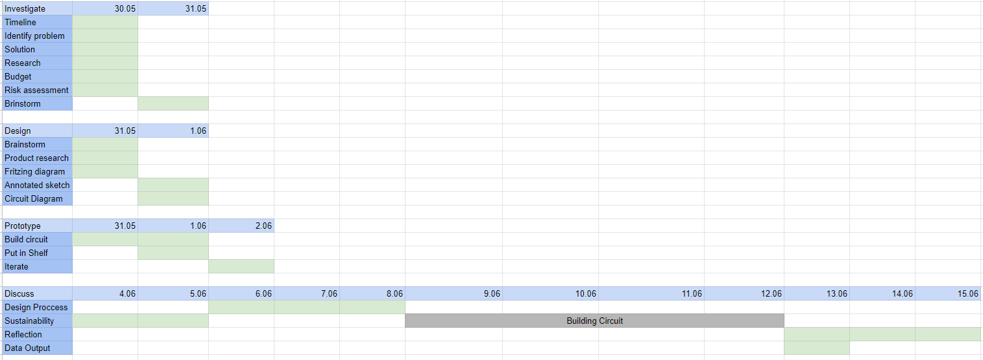

Research
The Canberra climate reduces the number of edible plants which can be grown successfully in the region (ACT Government, 2012). Canberra’s climate is considered a cold zone as shown by figure 1. Canberra sits at 9a on this graph indicating that the average minimum temperature is -7°C. This is generally not an ideal temperature for many plants especially for herbs and spices (The Diggers Club, n.d). Frost is the main issue when growing herbs in the ACT as we get yearly frost in the winter and sometimes autumn months.
When growing plants outdoors success relies on:
- The orientation of the garden as well as the shade covering
- the quality of soil present
- temperature and water
These are factors which can all be monitored and adjusted easily in an indoor environment.
The preferred growing temperature for herbs is 18°C to 30°C which is nearly impossible to maintain outside during Canberra winters (Rhoades, 2020).
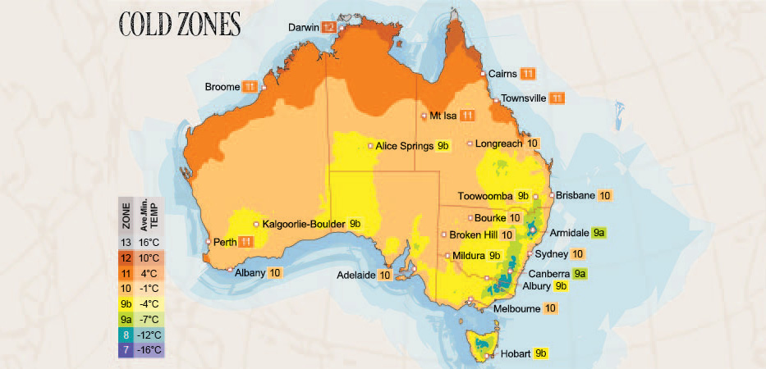
Figure 1
Budget
My budget for this task is $100. With this low budget a reasonable mark up on production costs will provide a good return in profits should the product become commercially manufactured. The average disposable income in Australia is $1,062 per week therefore should also be easily affordable for a majority of consumers (Australian Bureau of Statistics, 2019).

Development Model
For this task I am using the iterative development model. The iterative model involves the initial prototypes for testing in order to improve the final product for market. These improvements are based on user feedback of product functions and practicalities. The advantage of this method allows the product to come to its final form and ensures that it meets consumer expectations.
The iterative process allows the product to be continuously improved when there is need for it. With the iterative process it is important to identify any problems encountered after the release of the product so that they can be modified and improved in the next iteration. A disadvantage of using this model is that it benefits long timelines rather than short periods. For this assignment, since it was only a few weeks long, I believe that the model was less successful than if the task had been over several months. The iterative model can also not benefit some products. If the consumer does not like the first iteration, then they are unlikely to recommend it to others or purchase it again. Fallout 76 used the iterative approach to build the game but that backfired when people were finding lots of bugs in the code due to it only being one of the first iterations.
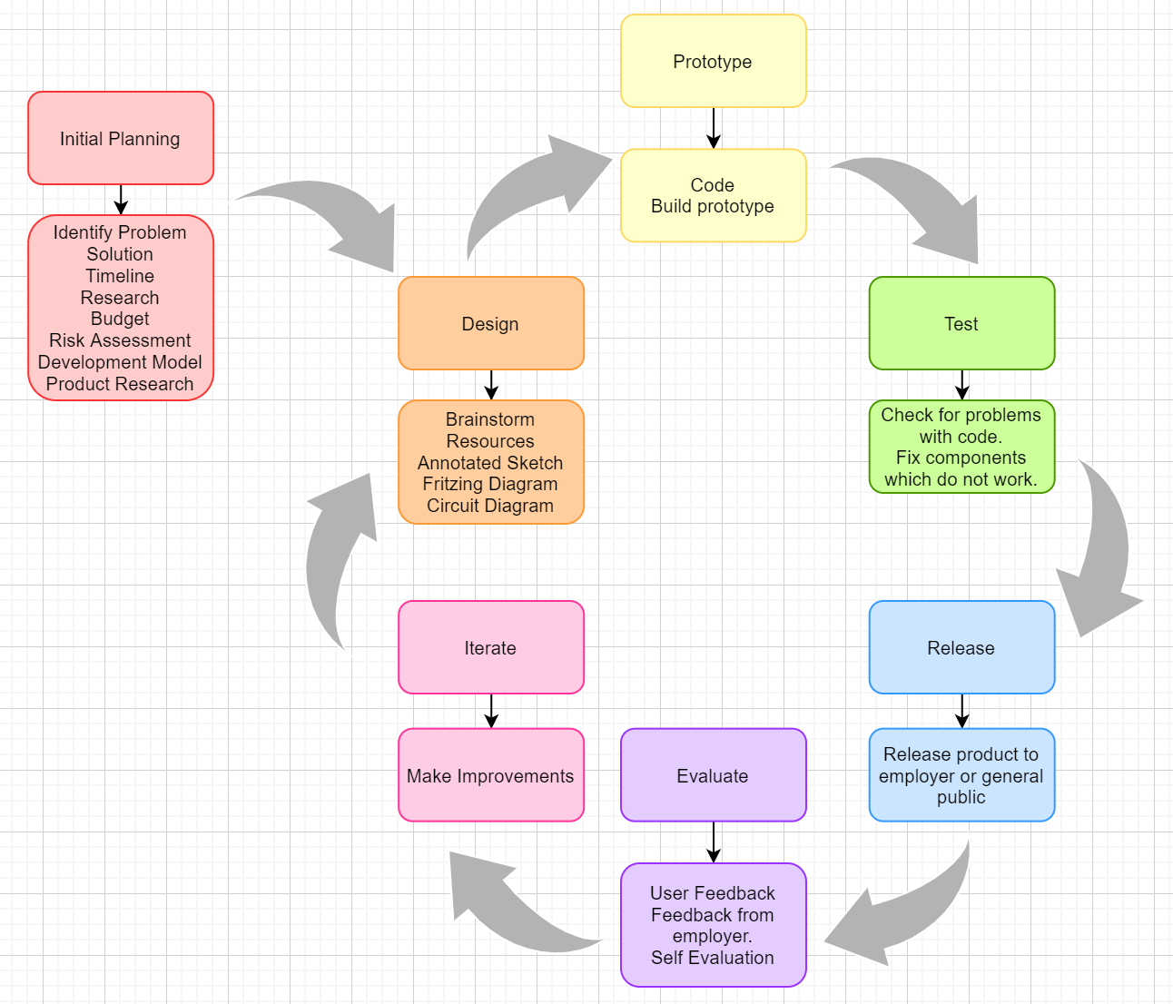

Design
Brainstorm

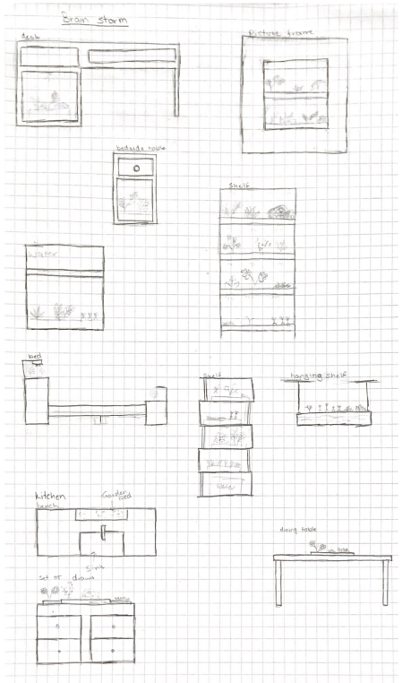

Product Research
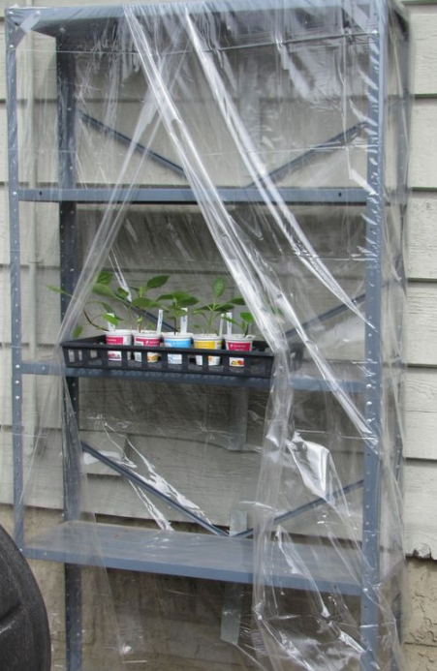 | This inspired the idea of an indoor edible plant shelf using planter trays. This model reduces the climate impact in which the plants are living and cause the plants to die. This design also allows many plants to grow in a small space. This is especially suitable for people who live in small homes or apartments where space is an issue. | (Garden Grow, 2014)
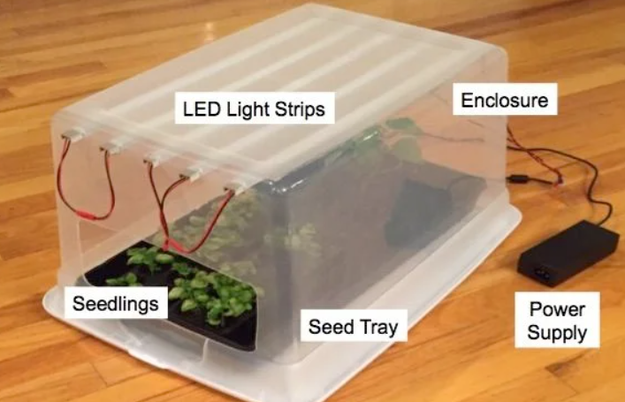 | This model triggered ideas of what other components could be added to my shelf. I liked the idea of LED lights because they would allow the shelf to be placed in dark locations that do not get much sunlight. It allows flexibility in the placement of the prototype. | (GreenThyme, n.d)
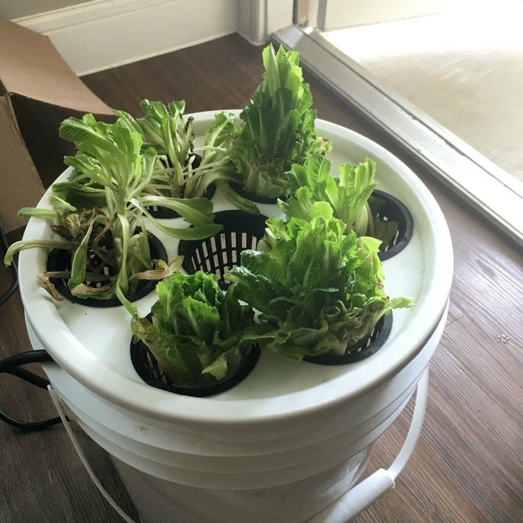 | This model uses hydroponics which is not what I wanted to use but gave me the idea to use a pump to make the system more hands off. The automatic watering means that forgetting to water or watering the plants too much are not an issue, and no one needs to water your plants when you travel because it is taken care of. | (evandromiami, n.d)
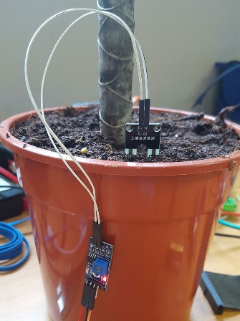 | A moisture sensor is crucial to the automatic watering system. Before I discovered there were soil moisture sensors the pump was going to be on a timer. However, the moisture sensor allows the watering system to be more accurate and better suited to a given environment. If the shelf is located in direct sun plants will need to be watered more often due to evaporation from the heat drying out the soil. | (The Pi Hut, 2017)
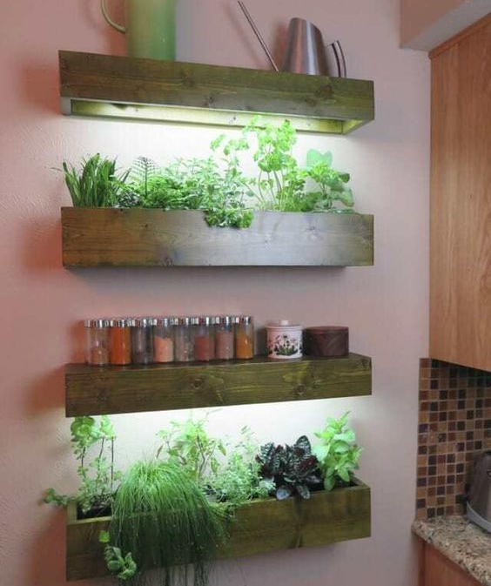 | This inspired the idea of having an indoor garden as it is easily accessible from the kitchen where herbs and edible plants are used. I liked the functionality of having an indoor garden which grows plants you can use. It can also become a practical design feature in the home. | (Kabir, 2019)

Resources
Object | Price | From
Soil Moisture Sensor x 2 | $14.85 | Jay Car
Relay | $12.95 | Jay Car
Temperature Sensor | $1.27 | (Ali Express, 2020)
Led Strip | $1.59 | (Ebay, 2020)
Shelf | $20.00 | The Green Shed
Arduino Mega | $9.54 | (Ali Express, 2020)
Plant Beds (cooking trays) x 2 | $14.99 | Ikea
Bread board | $5.05 | (Core Electronics, 2020)
PC fan x 2 | $6.00 | (Kogan, 2020)
Jumper Leads M/M | $1.99 | (Ali Express, 2020)
Jumper Leads M/F | $2.95 | (Core Electronics, 2020)
Power Pack x 2 | $5.11 | (Ali Express, 2020)
Total | $91.09

Annotated Sketch
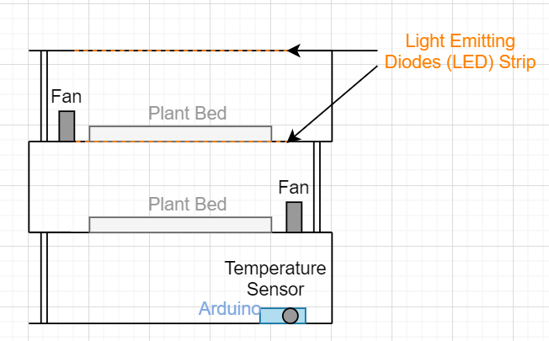

Fritzing Diagram
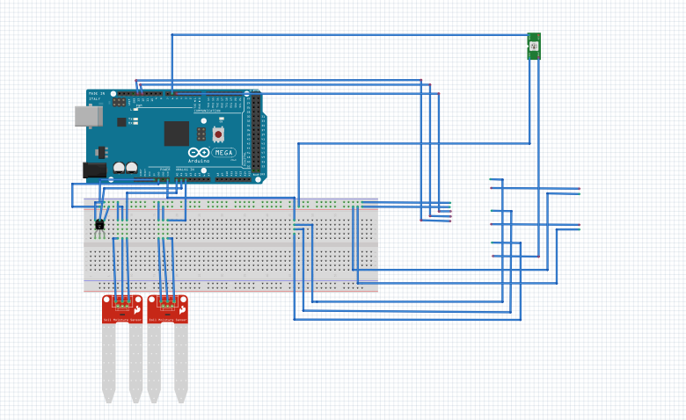

Relay
Fan
Fan
Circuit Diagram
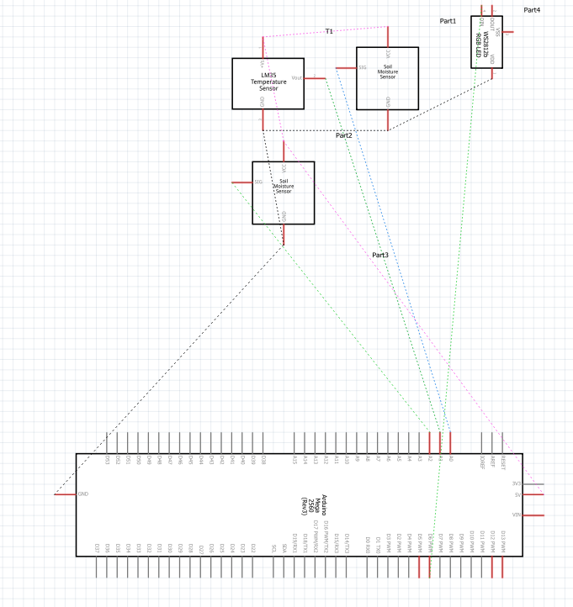

Prototype
Images
See images folder on Filr.
Code
See Real_World_V7 on Filr.

Moisture sensors
(Jaycar, n.d)
(MisterBotBreak, 2019)

Fans
(Arduino, 2015)

Count
(Arduino, 2010)

Iterate
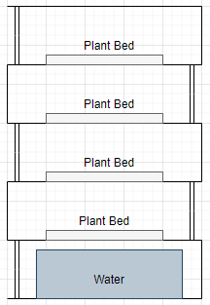
Iteration 1
To improve access to the plant beds I have decided to remove two tiers of the shelf. This also reduces the cost of the unit as it means that less jumper wires, sensors and other materials are required. The removal of the tiers also means that it is easier to transport and would be able to fit better in small indoor spaces. This iteration means that less plants will fit onto the shelf, but the sacrifice of the space will overall benefit the unit.

Iteration 2
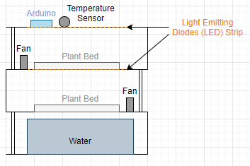
In this iteration to improve the design and safety of the product I decided to remove the water container. The bottom shelf became the location for the Arduino to sit on making it easier to hide the wiring to the outlet it is powered from. The removal of the water is so that none of the components get wet damaging the equipment or creating a safety hazard.
Future Iterations
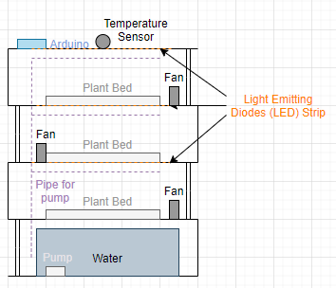
Future iterations of this product would include a pump, another tier and wireless connection to a phone. The pump would allow the system to become automated meaning that if the user were to travel or forget to water the plants it wouldn’t be a problem. Another tier would mean that more plants could be added to the shelf but to do that would mean exceeding the budget. Wireless connectivity to a phone would allow the user to see data related to the plant system and modify the conditions of the plants from anywhere. With wireless connection the user would not need to connect a laptop to the system every time they wanted to see data which can be dangerous if done improperly.

Communication
Reflection
I found this task extremely difficult due to the scale and complexity of my idea and my limited knowledge of programming Arduinos. For this task I used the iterative design process allowing me to build a prototype then have it tested by outside sources then iterate it to improve the useability of the product. I faced many problems throughout the creation of this product including issues with the code, the circuit and circuit components and Work Health and Safety (WH&S).
Due to my limited knowledge of the C programming language it took me a long time to figure out each section of the code. I decided to write the code myself to avoid plagiarism of others work. My method for the coding was to get one piece working at a time and this reduced the stress of having multiple errors from different circuitry components which would be overwhelming. By doing each part individually I was able to troubleshoot each individual component enabling me to see the problems with the code or circuit easily.
Along with problems in the code I also encountered issues with circuit components. I didn’t know how to use a lot of the components with an Arduino as some I have had no prior experience with, and others are recycled from other projects. The fans for example are old computer fans which were not being used for anything else so I decided that instead of throwing them away they could be useful to use in my circuit. In the process I discovered that drawing too much power from an Arduino can be dangerous which is why I have decided to use an Arduino mega and different power sources so that there are less components drawing power from the board.
When drawing too much power from the Arduino the components can become hot which I had not experienced before this task. Over the course of this task I burned myself two times touching the temperature sensor which I didn’t realise could happen. After this realisation I have added it to my risk assessment to encourage others to be aware of this problem and in future I will research on hazards of components I have not used before.
To solve the problems encountered during this task I have used a troubleshooting method and an external programmer. To troubleshoot problems, I took away each different variable until I found the source of the issue. For example, when the relay was not working, I tested it on a working channel with the same result. I then tested it on another pin which also didn’t work meaning the only issue was something to do with the code. This method proved to be successful in finding where the issue was so I could fix it where necessary. The external programmer helped me to get the computer fans working on the Arduino and taught me how to use a relay.
To efficiently use my time, I created a Gantt chart, so I had goals to work towards. For the most part I stuck to the chart, but the building of my circuit took longer than expected. Frustratingly this meant that the rest of my work was pushed back and delayed. Luckily, I had some scheduled time at the end for any tasks which took longer than expected which was the case for this task
The data from the soil moisture and temperature sensors were tested using small lengths of wire in a test environment. If this was a commercial product the sensors would need to be calibrated to accommodate for resistance added by longer wires.

Data
The data I collected is based off the needs for plants. I collected data on the soil moisture and temperature serve to create a suitable environment in which plants can thrive. My data shows how the plants environment changes over the course of the day and adjusts to the changes to help the plants grow.
Soil Moisture
Figure 2
Temperature
Figure 3
The data collected in figures 2 and 3 show the environment in which plants are growing. This data allows the user to select plants best suited to the climate or modify the climate to suit plants. The drops in temperature are due to the fans switching on and off and the increases in this case were simulated as a proof of concept. The fans are controlled by the recorded temperature from the sensor. In later iterations the moisture sensors would control a pump and would be controlled through a relay.
The application of this data is to inform the user of climate and climate changes that can impact the growth of plants. The system also makes gardening easier for people who are not practiced and have little knowledge of gardening.
This data was taken under testing conditions and therefore is not an accurate reading of the climate. The data was collected to show the viability of this method and to demonstrate the type of data that can be collected from this unit. If this model was to be used outside of a tested environment, then calibration of the sensors would be required.
Sustainability
Arduinos can be used with parts from computers and other electronics such as speakers and GPU’s allowing people to reuse parts, reducing e-waste (Arduino, 2012). Arduino components can be recycled for the metal parts and generally can be used to replace parts in other Arduinos. Arduino jumper leads can also be stripped and used for the metal inside. There are two methods of recycling printed circuit boards (PCB) (Staley, 2015). Shredding requires large machinery and enables the metals in the boards to be reused. Dismantling allows the re-use of smaller components and is usually done for components such as LED, resistors and motors but can be done for PCB’s and larger components (Staley, 2015).
Many mining companies have now adopted more ethical mining practices which result in lower death tolls and less harm to the environment. Many nations are assisting with the battle to maintain sustainable and ethical mining practices with many new regulations about where mining can be done and methods of mining (BSR, 2014).
If this product were to be manufactured for commercial sales the manufacturing locations would have to be carefully selected to avoid exploitation and child labour which would be bad for the reputation of the brand and ethics.
For this prototype I have tried to use as many recycled materials as I could. The recycled components I have used are the shelf, power packs and computer fans. I have reused 2 old computer fans to make a cooling system for the plants.
The wires I used were stranded core copper wires which can all be recycled at one of many metal recycling places in Canberra including Metalmart, Jack Martin Scrap Metals or Access Recycling Canberra. Copper mining is currently not very ethical as it damages the environment, but governments are beginning to adopt strict regulations for mining to reduce the damage to the environment and the danger to people (Hancock, 2001).
Design Process
The design process provides a template to assist in decision making for aspects of the project. Through design aspects like brainstorming and sketching, designers can evaluate other options and potential opportunities for their project.
With a clear plan, less resources are used and there are less mistakes and design changes during the prototyping and iteration stages. By saving time with less mistakes the designer can focus on making an overall better product.
Not all the parts of the design process are needed for every project. For example, this project being an assignment does not have a set budget and is just made up whereas a project done in a workplace would have one.
The design process is extremely flexible allowing modifications to best suit the needs of the project and can suit both a school and work environment.

Bibliography
ACT Government, 2012. Microclimate. [Online]
Available at: https://www.actsmart.act.gov.au/__data/assets/pdf_file/0004/546259/WRG-Microclimate.pdf
[Accessed 1 June 2020].
Ali Express, 2020. Ali Experss. [Online]
Available at: https://www.aliexpress.com/all-wholesale-products.html
[Accessed 30 May 2020].
Arduino, 2010. Topic: counting. [Online]
Available at: https://forum.arduino.cc/index.php?topic=43295.0
[Accessed 6 June 2020].
Arduino, 2012. Harvesting Components from devices. [Online]
Available at: https://forum.arduino.cc/index.php?topic=66255.15
[Accessed 3 May 2020].
Arduino, 2015. Topic: Conecting cpu fan?. [Online]
Available at: https://forum.arduino.cc/index.php?topic=160353.0
[Accessed 7 June 2020].
Australian Bureau of Statistics, 2019. 6523.0 - Household Income and Wealth, Australia, 2017-18. [Online]
Available at: https://www.abs.gov.au/household-income#:~:text=6523.0%20%2D%20Household%20Income%20and%20Wealth%2C%20Australia%2C%202017%2D18&text=In%202017%E2%80%9318%2C%20the%20average,income%20was%20%241%2C062%20per%20week.
[Accessed 2 June 2020].
BSR, 2014. How Can Business Contribute to the Ethical Mining of Conflict Minerals?. [Online]
Available at: https://www.bsr.org/reports/BSR_Ethical_Mining_Conflict_Minerals.pdf
[Accessed 4 May 2020].
Cooper, T., 2012. Usage. [Online]
Available at: https://learn.adafruit.com/rgb-led-strips/usage
[Accessed 10 June 2020].
Core Electronics, 2020. Core Electronics. [Online]
Available at: https://core-electronics.com.au/
[Accessed 1 June 2020].
Ebay, 2020. Ebay. [Online]
Available at: https://www.ebay.com.au/
[Accessed 1 June 2020].
evandromiami, n.d. Lettuce for Life - Arduino 101 Based Automated Controller for Hydroponics, Aeroponics, Aquaponics, Etc. Intel Curie. [Online]
Available at: https://www.instructables.com/id/Lettuce-for-Life-Arduino-101-Based-Automated-Contr/
[Accessed 5 June 2020].
Garden Grow, 2014. Geek Gardening. [Online]
Available at: http://slcwatchgardengrow.blogspot.com/2014/07/geek-gardening.html
[Accessed 5 June 2020].
GreenThyme, n.d. Green Thumb Grow Lights. [Online]
Available at: https://www.instructables.com/id/Green-Thumb-Grow-Lights/
[Accessed 5 June 2020].
Hancock, P., 2001. Sustainable Development and the Australian Minerals Sector. [Online]
Available at: https://www.aph.gov.au/About_Parliament/Parliamentary_Departments/Parliamentary_Library/pubs/rp/rp0001/01RP24
[Accessed 13 June 2020].
Jaycar, n.d. Portable Soil moisture meter. [Online]
Available at: https://www.jaycar.com.au/soil-moisture-meter
[Accessed 5 June 2020].
Kabir, 2019. Top 7 Best 900 Watt Led Grow Light Review. [Online]
Available at: https://www.allledgrowlights.com/900-watt-led-grow-light/
[Accessed 4 June 2020].
Kogan, 2020. Kogan. [Online]
Available at: https://www.kogan.com/au/
[Accessed 1 June 2020].
MisterBotBreak, 2019. How to Use a Soil Moisture Sensor. [Online]
Available at: https://create.arduino.cc/projecthub/MisterBotBreak/how-to-use-a-soil-moisture-sensor-ce769b
[Accessed 6 June 2020].
Rhoades, H., 2020. Indoor Herb Garden – How To Have An Herb Garden Inside. [Online]
Available at: https://www.gardeningknowhow.com/edible/herbs/hgen/growing-herbs-indoors.htm#:~:text=The%20herbs%20will%20grow%20best,temperatures%20can%20kill%20some%20herbs.
[Accessed 4 June 2020].
Smith, J., 2018. Make a fan turn on automatically when the room temperature reaches a certain degree.. [Online]
Available at: https://maker.pro/arduino/projects/how-to-make-a-temperature-controlled-fan-using-arduino
[Accessed 13 June 2020].
Sparkfun, 2003. µA7800 Series Positive Voltage Regulators. [Online]
Available at: https://www.sparkfun.com/datasheets/Components/LM7805.pdf
[Accessed 8 June 2020].
Staley, A., 2015. PCB Recycling: The Core of Your Electronics Is More Valuable Than You Think. [Online]
Available at: https://www.open-electronics.org/pcb-recycling-the-core-of-your-electronics-is-more-valuable-than-you-think/
[Accessed 3 May 2020].
The Diggers Club, n.d. CHOOSING THE RIGHT PLANTS FOR YOUR CLIMATE. [Online]
Available at: https://www.diggers.com.au/shop/ordering-information/climate-maps/
[Accessed 2 June 2020].
The Pi Hut, 2017. Raspberry Pi Plant Pot Moisture Sensor with Email Notification Tutorial. [Online]
Available at: https://thepihut.com/blogs/raspberry-pi-tutorials/raspberry-pi-plant-pot-moisture-sensor-with-email-notification-tutorial
[Accessed 5 June 2020].

