Title of AUBEA 2025 Conference Paper
Larry Hu^{1*}, Amy Wei¹ and Hitomi Nakanishi¹

¹School of Design & Built Environment, University of Canberra,
Kirinari Street, Bruce ACT 2617, AUSTRALIA

larry.hu@canberra.edu.au; amy.wei@canberra.edu.au; hitomi.nakanishi@canberra.edu.au
* Corresponding author

Abstract:
The abstract of your paper should be written in a single paragraph within 250 words. A good abstract should give a brief overview of the paper including the background and/or rationale, the research methodology, and the findings from the research. It is also a good practice to explain how the findings from the research are useful in solving problems or minimising gaps in the specific area/field/communities/industry. The abstract should not have in-text citations.
Keywords:
Up to 5 keywords should be provided in alphabetical order separated by commas

Introduction
This document can be used as a template for your paper by applying the styles given. Your full paper should not exceed 10 pages including the References section and consist of at least the following components: an Abstract, an Introduction, a Literature Review, Research Methodology, Findings and Discussion, Conclusion and Further Research and References. The introduction section should provide an overview of the article as well as the background and context of the paper. Starting from general to provide the ‘big picture’ moving down to specifics, this section should provide a rationale that justifies the research, i.e. why there is a necessity to conduct a research on this particular subject. This can be done by providing evidence of problems that need solutions and/or an identified knowledge gap in a specific domain, level, geographical location, society, sector, industry, and so on supported by key references. As the response, a clear research agenda can be described specifying research aim and objectives in order to clarify the purpose of conducting the investigation.
The introduction is not a literature review and hence, critique is not included in the introduction. The introduction should also not outline the structure of the paper, as the contents are self-evident in the paper. Paper structure, section headings and sub-headings in this template only serve as a guide. These align more with empirically based research. AUBEA notes that it is not possible for every conference paper to follow this guide as some papers are systematic literature reviews, case studies, action research, among others. Nevertheless, authors must explain how the research was undertaken to attain the set aim and objectives in the paper. The explanation must highlight the research design, collection of data, and analytical methods adopted in the research.

Literature Review
Similar to the background and context discussed in the introduction section, the literature review should flow from general to specific. The manuscript must contain a critical review of literature or theory(ies) relevant to the research. This is important in establishing how the work reported builds on the current body of knowledge by either challenging or expanding on it. Clear citations must be added to underpin the literature that forms the basis of the research. Theoretical positions define specific aspects of the literature whether explicit or implied. The literature review culminates in a conceptual framework or research hypotheses. This brings the literature review to an end or begins the research design.
The referencing system used should be the Harvard system. There are several variances in styles that can be adopted, however for consistency, the following style should be applied in writing the AUBEA 2022 full paper: (Perera, 2022) or (Jin and Osei-Kyei, 2021; Hassan and Feng 2020) or (Hardie et al., 2019; Senaratne et al., 2018). Please note that for more than two authors, only the surname of the first author appears followed by “et al.” in italic, a comma, one space and then the year of publication. In the case of more than one articles referenced as shown in the above example, a semi colon (;) has to be added in between followed by one space.
The heading for section 2 does not necessarily need to be called “Literature Review”. It may be any heading that best represents the content of the review of literature of the paper. Examples include: Theoretical framework, Conceptual framework, Maturity model in mental health management, etc.

Nesting Sub-sections
Starting from section 2 onwards (except for the References section), nesting sub-sections can be added whenever necessary by selecting “A22 Heading 2” or “A22 Heading 3” as appropriate.

The Level of Sub-section Nesting
Authors are not advised to use more than three levels of sub-section nesting. The use of too many nesting levels will reduce clarity and may be confusing for the readers of your article.

Research Methodology
The research methodology section must elucidate the approach and/or the research design, data collection, and data analysis methods utilised in the research in such details that they may be replicated. The suitability of the selected methodology over other options/alternatives should be justified with academic basis.
In the event samples are used, the study population must be defined; the method of selecting the sample and the response rate should be stated as should any attempt to establish if the sample or response is biased. All statistical or other quantitative analyses must be checked carefully for applicability and accuracy before submission.
Some papers present very early stages of the research. This should not prevent the author to discuss potential research methodology that can be adapted based on the nature of the research problems/questions identified or type of data expected at this stage. Research is iterative in nature and researchers continuously modify their research methodology in light of new information and changes in circumstances.

Findings and Discussion
In this section, authors should discuss all the findings emerging from conducting the investigation so far. Even for early stages of research (e.g. the paper may only aim to report an initial literature study), what has been synthesised from the literature should be discussed. This may be done by highlighting the similarities and/or differences from a variety of literature sources on the issues being investigated and the contextual nature of the similarities/differences (such as geographical locations, culture, or many other factors that may influence the discussion in those different literature sources).
In the case of papers reporting further stages of research, findings from the investigation should be clearly presented, followed by an analytical discussion of the findings. This can be done, for instance, by critically demonstrating how the findings relate to the current body of knowledge in or relevant to the field of investigation. For papers reporting completed investigation (or very close to completion), recommendations (for improvement) should be offered by the authors based on the data analysis and discussion of the findings. This section represents one of the most important parts of the discussion which presents the main contributions of the paper.
Tables, figures, and equations can be used in sections 2, 3, and 4 to better explain the findings. All tables, figures, and equations must be cited in the body of the paper appropriately. All tables should be left-aligned with the table caption numbered and placed above the table, as shown below. Do not use font sizes smaller than Times New Roman 10 pt for text in tables.
Table 1. Occurrence of the decision resulted from a two-decision-makers condition
(Source: Sutrisna and Potts, 2004)

 | R¹ | R² | R³ | R⁴ | R⁵ | R⁶ | R⁷ | R⁸ | R⁹
L | 45% | 11% | 0% | 0% | 45% | 0% | 11% | 22% | 0%
L-M | 22% | 11% | 0% | 0% | 11% | 11% | 0% | 11% | 11%
M | 22% | 78% | 78% | 22% | 11% | 78% | 11% | 45% | 45%
M-H | 0% | 0% | 11% | 22% | 0% | 11% | 11% | 0% | 11%
H | 0% | 0% | 11% | 45% | 11% | 0% | 45% | 11% | 22%
Inconclusive | 11% | 0% | 0% | 11% | 22% | 0% | 22% | 11% | 11%

All figures should be left-aligned with the caption numbered and placed under the figure. High-resolution figures with legible text (if any) should be provided. The figure caption should be numbered and positioned below the figure as follows.
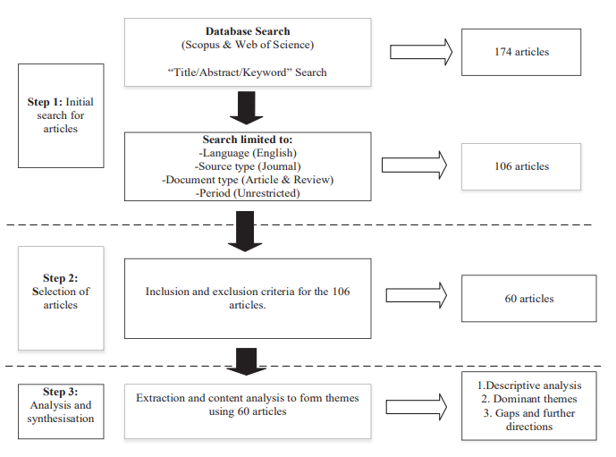
Figure 1. Research Methodology flowchart
Source: Akomea-Frimpong et al. (2021)

Conclusion and Further Research
The conclusion section should present the new insights offered in your research and as reported in the manuscript. These insights may relate to new theoretical contributions and how the research findings agree with or challenge existing theories. The conclusion should also include the practical implications of the research. For systematic literature review papers, a highlight may be made on how the consolidation of the existing body of knowledge contributed to improving policies and practices. The conclusion section must tie in with the research aim, objectives, and also present the major contributions of the research.
The conclusion must include a brief mention on the limitations of the study and recommendations for future research. Limitations in this context imply the limits/boundaries of applicability of the research. Recommendations for future studies must therefore indicate the steps that should be taken to expand the applicability of the research. For ongoing research, this may include the next stages of the research that will be conducted by the researcher to complete the research. Ideally, this section should demonstrate the contribution of the research and also this paper (as summarised) as well as inspiring other researchers to further develop the body of knowledge in the relevant field.

Acknowledgement
Authors may have to provide acknowledgement for any funding support they received for the research. Acknowledgement can also be indicated for other forms of support that were provided by individuals or organisations. This section should be used for such purposes. If no acknowledgement is necessary, delete this section from the manuscript.

References
Author1, Initials., Author2, Initials. and Author3, Initials. (Year), ‘Article Title’, Journal Title, Volume (issue no.), pp 20-32.
Author1, Initials., Author2, Initials. and Author3, Initials. (Year), Book title, Publisher, Place.
Author1, Initials., Author2, Initials. and Author3, Initials. (Year), ‘Article Title’, In: Editor(s), Book Title, Publisher, Place, pp 20-32.
Author1, Initials., Author2, Initials. and Author3, Initials. (Year), ‘Article Title’, In: Editor(s), Conference Proceeding, Publisher, Place, Dates of Conference, pp 20-32
Author1, Initials., Author2, Initials. and Author3, Initials. (Year), ‘Article Title’, Publication/Publisher, http://www.url_address.co/article1.htm, viewed: 31/01/2022.

