Feedback opportunity: External Faculty Review of the Faculty of Health

208
Responses

14:40
Average time to complete

Closed
Status

- What is your relationship with the Faculty of Health? Please choose all that apply
(0
point)

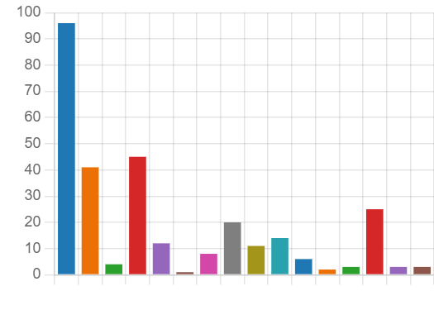

Faculty student - undergraduate | 96
Faculty student - postgraduate | 41
Faculty student - Higher Degree… | 4
Faculty domestic student | 45
Faculty student identifying from… | 12
Faculty student identifying as A… | 1
Faculty international student | 8
Faculty Academic staff member | 20
Faculty Professional staff member | 11
Faculty alumni | 14
Faculty external partner | 6
Other UC student (ie: From anot… | 2
Other UC Academic staff member | 3
Other UC Professional staff me… | 25
Other UC external partner | 3
Community member | 3

- If you are Faculty alumni, what year did you graduate? (0 point)

24
Responses Latest Responses

4 respondents (16%) answered 2021 for this question.
PhD
Educ
No
2004
1988
2023
2013
2021 202
2020
2019
20

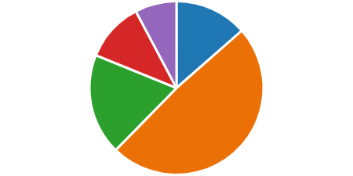
- The Faculty has a good reputation for the quality of its courses and teaching.
(0
point)

Strongly agree | 28
Agree | 101
Neutral | 39
Disagree | 23
Strongly disagree | 16

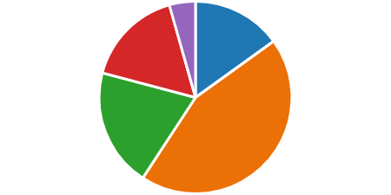
- I believe students are well-prepared to begin their professional careers when they graduate.
(0
point)

Strongly agree | 31
Agree | 91
Neutral | 41
Disagree | 34
Strongly disagree | 9

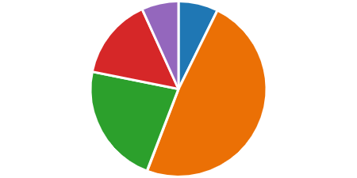
- The Faculty works to maximise opportunities for innovation in teaching and learning.
(0
point)

Strongly agree | 15
Agree | 100
Neutral | 46
Disagree | 31
Strongly disagree | 14

- Please add any comments on learning and teaching. (0 point)

82
Responses
Latest Responses
"The staff are excellent at catering to students unable to atte…

40 respondents (49%) answered students for this question.
expectations on students
study with other students
student in the co
psychology students teaching staff
pass student
learning
studentstime
graduate students
attitude with
support
Current students Health students
covid for students
health degrees
placements stu
students education
students a

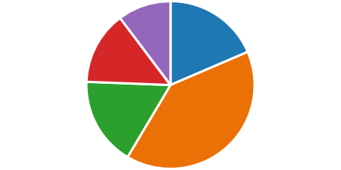
- The Faculty provides high quality support for students and their learning. (0 point)

Strongly agree | 38
Agree | 82
Neutral | 35
Disagree | 29
Strongly disagree | 21

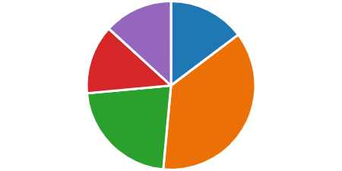
- The Faculty responds to student concerns and issues. (0 point)

Strongly agree | 30
Agree | 75
Neutral | 45
Disagree | 27
Strongly disagree | 27

- Please add any comments on the student experience. (0 point)

78
Responses
Latest Responses
"Faculty is quick to respond to any concerns"

46 respondents (60%) answered students for this question.

feedback from student support to students
students

Worked well with students students have questioned

students are in need teaching staff
Student Centre university
student rep HDR students

student experience

staff
course
student su student co

students do placements
students and students
student learni

- Professional Faculty staff only - I feel supported as a professional Faculty staff (0
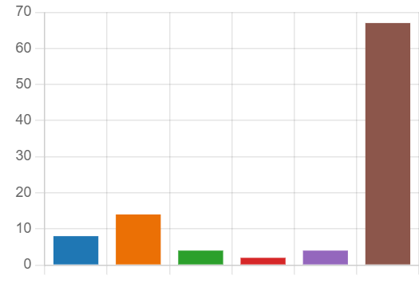
member to succeed. point)

Strongly agree | 8
Agree | 14
Neutral | 4
Disagree | 2
Strongly disagree | 4
Not applicable | 67

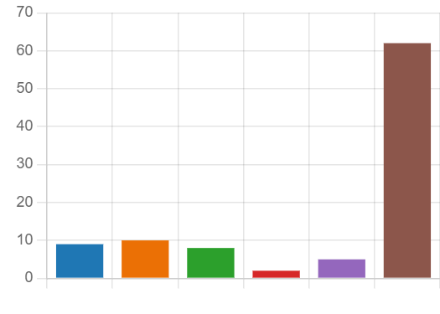
- Academic Faculty staff only - I feel supported as an academic Faculty staff member to succeed.
(0
point)

Strongly agree | 9
Agree | 10
Neutral | 8
Disagree | 2
Strongly disagree | 5
Not applicable | 62

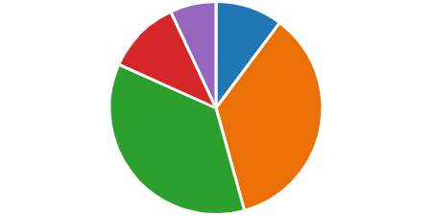
- Please add any comments on staff support. (0 point)

17
Responses Latest Responses

4 respondents (24%) answered professional staff for this question.
support or response
opportunities universitiesyear
administrative support
workload professional staff
work
support of assignments academic staff UC staff supported
better support
support in the Faculty
staff

staff me
supprt from any staff
Staff are amazi

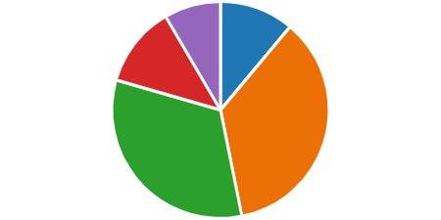
- The Faculty is well managed. (0 point)

Strongly agree | 21
Agree | 68
Neutral | 62
Disagree | 23
Strongly disagree | 16

- The Faculty has clear policies and governance structures. (0 point)

Strongly agree | 19
Agree | 66
Neutral | 67
Disagree | 21
Strongly disagree | 13

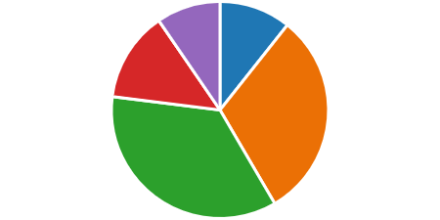
- Communication from Faculty leadership to Faculty members is clear and effective.
(0
point)

Strongly agree | 19
Agree | 55
Neutral | 63
Disagree | 24
Strongly disagree | 17

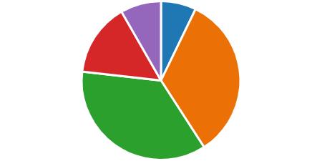
- I believe there are efficient and appropriate quality assurance and compliance processes embedded in Faculty structures.
(0
point)

Strongly agree | 13
Agree | 61
Neutral | 65
Disagree | 27
Strongly disagree | 15

- Please add any comments on Faculty governance. (0 point)

37
Responses
Latest Responses
"I am not overly knowledgeable regarding facukty governance"

12 respondents (33%) answered students for this question.
comments re governance
student time
policies
Faculty governance
staffstudents
teaching staff
disagreements in front of student
structures in place
Faculty
levels of those students
governance structures university
communication
work for staff
governance/compliance
high governa
student
number of st

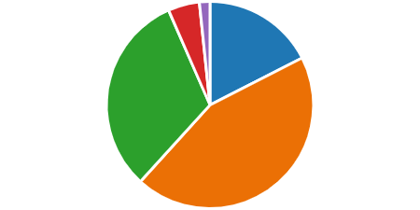
- The Faculty's research output is of high quality. (0 point)

Strongly agree | 32
Agree | 81
Neutral | 58
Disagree | 9
Strongly disagree | 3

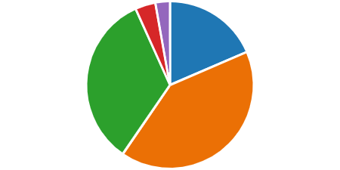
- The Faculty's research output supports the University's strategic research goals.
(0
point)

Strongly agree | 33
Agree | 73
Neutral | 60
Disagree | 7
Strongly disagree | 5

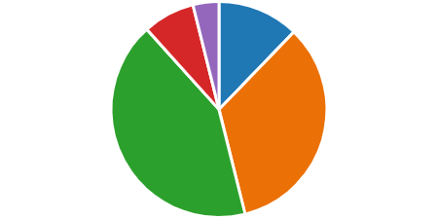
- The Faculty's research maximises innovation opportunities. (0 point)

Strongly agree | 22
Agree | 61
Neutral | 76
Disagree | 14
Strongly disagree | 7

- Please add any comments on research and innovation. (0 point)

28
Responses Latest Responses

16 respondents (57%) answered research for this question.
facutly's researchteaching research and innovation
research equipment
student was unable

honours student
UC research
high research
Research str research i
student researc
area
Faculty
resear
innovative research
research output
Participation in research
research obli

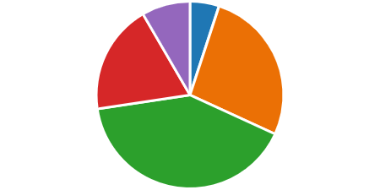
- The Faculty's human resources are well managed. (0 point)

Strongly agree | 9
Agree | 48
Neutral | 73
Disagree | 34
Strongly disagree | 15

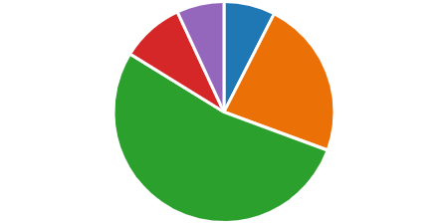
- The Faculty's financial resources and any other resources are well managed.
(0
point)

Strongly agree | 13
Agree | 40
Neutral | 92
Disagree | 16
Strongly disagree | 12

- Please add any comments on Faculty resources. (0 point)

34
Responses Latest Responses

12 respondents (35%) answered resource for this question.
students and staff staff have to worksupport faculty resources staff
staff shortages financial resource
resource
Faculty of Health
staff team
High
human resources
faculty do it for
students
faculty professi
people and resourcesresource manag
students with

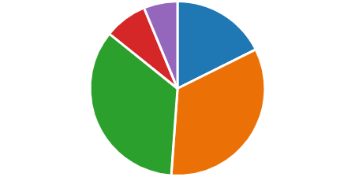
- The Faculty's leadership has a vision for the Faculty's future success. (0 point)

Strongly agree | 31
Agree | 59
Neutral | 61
Disagree | 14
Strongly disagree | 11

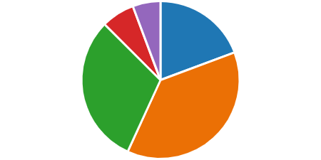
- The Faculty is committed to developing strong and meaningful relationships with external bodies, agencies and stakeholders.
(0
point)

Strongly agree | 34
Agree | 66
Neutral | 54
Disagree | 12
Strongly disagree | 10

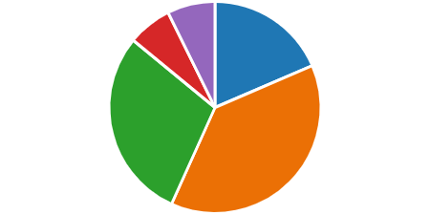
- The Faculty is well known and respected across the wider university community.
(0
point)

Strongly agree | 33
Agree | 68
Neutral | 52
Disagree | 12
Strongly disagree | 13

- Please add any comments on the Faculty's future direction. (0 point)

27
Responses Latest Responses

7 respondents (26%) answered faculty for this question.
nursing students
school students support
faculty has a vision
UC
Health Faculty
students behalf university
faculty members Strategic plans
faculty students Fac
research
high
course
reflection of the faculty fields within the fac

- Please list up to three areas that you think the Faculty does well. (0 point)

120
Responses
Latest Responses
"Accessibility, feedback"
"Involvement with students, approachability, clear guidelines " "student support"

48 respondents (41%) answered students for this question.
Communication with students
professional student
Supports their students caring for students health stu
academic staff
student experience courses
studentsstaff
High quality
student learning
HDR student
work
Student support
students t Research teaching staff
supportive of students
good teaching

30. Please list up to three areas where you think significant improvement is required.
(0
point)

131
Responses
Latest Responses
"Community engagement"

49 respondents (38%) answered students for this question.
student experience
student learning impacts for m
student complaints
individual students needs studentsstaff
Communication with students
student placementsstudent
teacher student feedback
supporting students teaching staff students support enga
time students staff and students International students

- What areas or opportunities should the Faculty focus on for development, innovation and future directions?
(0
point)

92
Responses
Latest Responses
"Community engagement, rural/regional student support"

28 respondents (31%) answered Student for this question.
education rather than a research
age stu
Student input research
student wellbeing
student learning
course Student
faculty
student
health
HDR
work
opportunities OT
process for students
Units
Student support
Student experience
att

- Any further comments? (0 point)

38
Responses
Latest Responses
"Thank you for this opportunity!"

18 respondents (49%) answered student for this question.
students will be able diversity among students kind
students and lack Health student Faculty student
experience for us as students
student comments int
level students
students or academics
course student in the FoH
staff opportun
age students
issue for SO many

