Appendix 1: Steps in Student Grievance Resolution Process
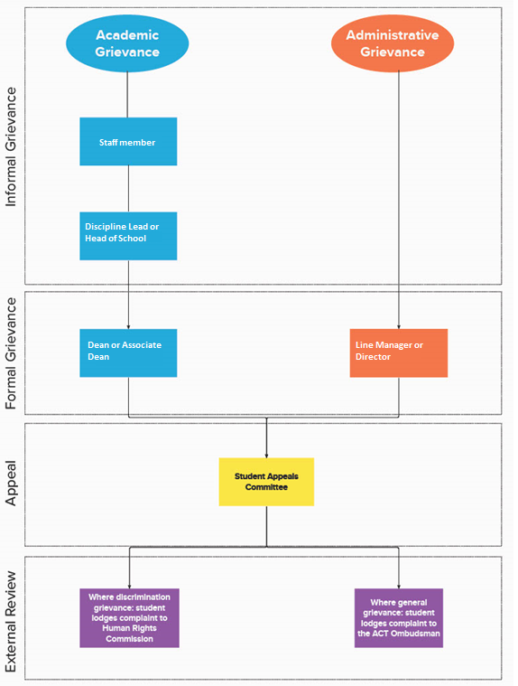
This flowchart identifies the most appropriate party to consider a student’s grievance at each step of the student grievance resolution process.

